CAREER DEVELOPMENT SERVICES
(Renovations)
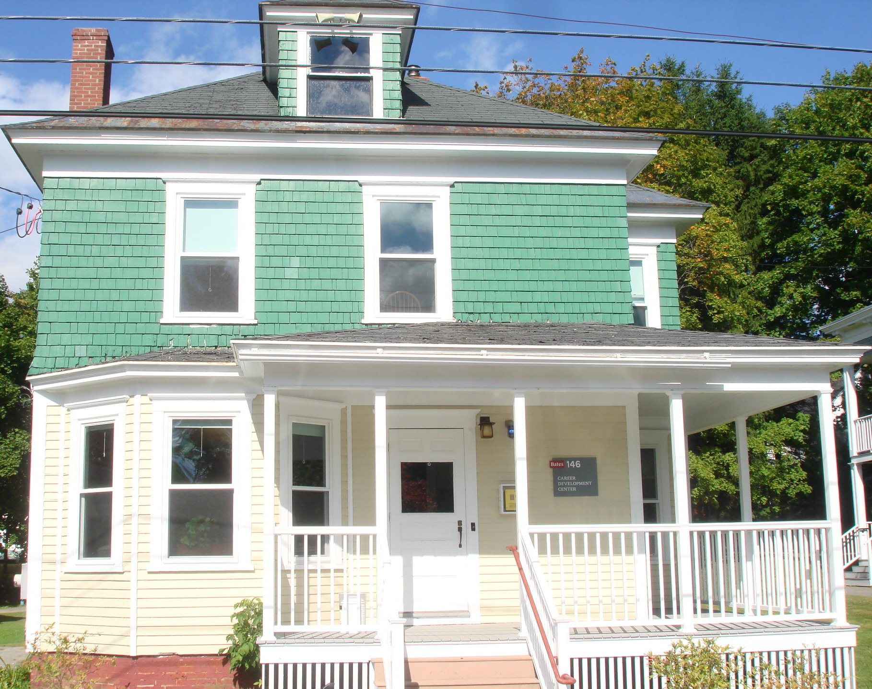
Architect: Facility Services General Contractor: Bates College
Year Complete: 2014 Total Square Feet: 2,740 (Renovations)

Programmatic Drivers:
Enabling move. Canham house, an underutilized building, was renovated to house the Bates College Career Development Center because their existing facility was to be demolished making way for the new Campus Avenue Housing Project.
The main Reception area received a facelift by opening up the area and adding new lighting to make it more inviting. All of the offices had the original wood floors refinished and new paint.
The building received all new windows, a new electrical service and completely new data and phone wiring. The front porch was renovated to match the nearby residential dorm buildings.

