Uploading the Exam Version of a Bates Honors Thesis to
SCARAB

You must upload your thesis and an updated thesis abstract no later than 3:00 p.m. Friday, March 27, 2015. At this stage of the process, the thesis will only be available to the examination panel.

Instructions for Candidates
To submit, you must have your thesis in an electronic format. SCARAB allows you to upload one thesis file only. The updated abstract is pasted into SCARAB separately. Suggested file types for the thesis are listed below. In cases where a thesis is comprised of multiple files (e.g. an artist statement and the actual composition(s)) you must package all files together in a single zip file. You must then upload the zip file. If you need help creating zip files, please see the Bates Help Desk in Ladd Library.

Content Type | Suggested File Type  Content Type Suggested File Type  3D Models 3ds  Compressed files/folders zip  Tabular data csv
Text | pdf
Audio | mpeg3
Image | Jpg
Video | mpeg4

Uploading the Thesis

From any computer connected to the internet, open a browser and go to: http://scarab.bates.edu/ Select “My Account” in the upper right corner.
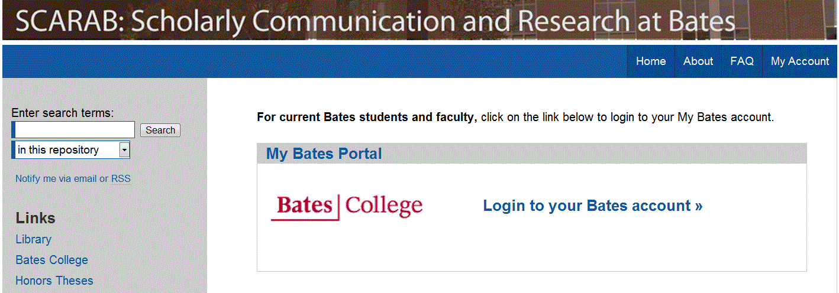
In the “My Bates Portal” box, click on “Log in to your Bates account >>” and enter your complete Bates email address and Bates password.

In the “Author Corner” near the bottom of the left-hand column, click the “Submit Research” link.

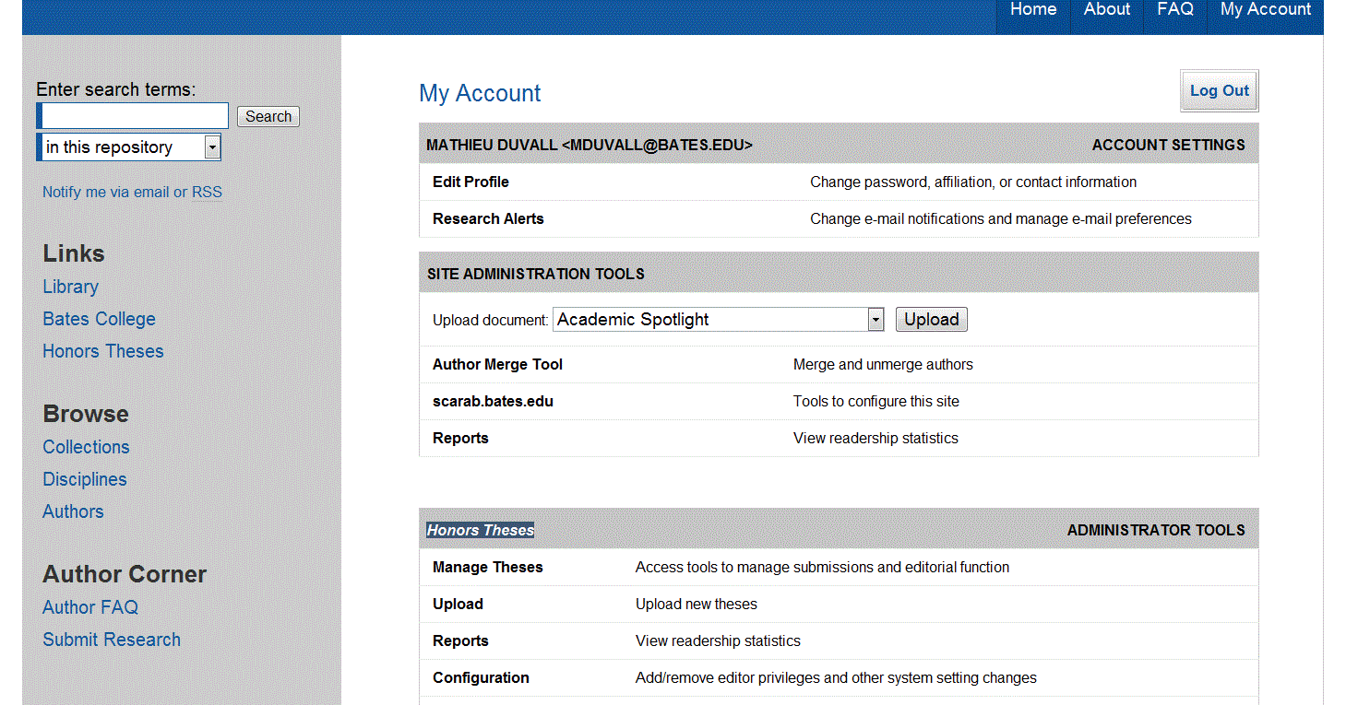

On the “Submit Your Research” screen click “Honors Thesis” at the bottom of the page.

The Submission Agreement

On the following page, you will find submission instructions and a submission agreement. Check it to move forward. If your thesis is awarded honors, you and your advisor must sign and submit by May 8, 2015, the Thesis Access and Embargo form pertaining to the legal aspects of publishing your work. The wording on that form is the same as the wording on the first page of the SCARAB form and reads:

I Affirm:
• That this work is my original creation and that I have full authority to make this agreement;
• That my thesis does not contain any libelous matter, nor invade the privacy of any person or third parties;
• That, if my thesis includes materials copyrighted by another party and used by me in excess of the fair use provision of the United States copyright code, I have restricted access to the final version of my thesis to the Bates educational community only.
• I grant Bates College the non-exclusive right to make my thesis part of SCARAB and to make it available for research and scholarly purposes. I understand that once the final thesis is uploaded, I may not remove it.
Check the box to confirm that you have read the submission agreement and click “Continue” at the bottom of the screen to move to the submission form.
The Submission Form
You will need to enter the following information into the submission form when you upload your thesis:
• Thesis title
• Author (Your name)
• Date of Graduation (Use May 31, 2015.)
• Level of Access (Select “Open Access” when you first submit your thesis. Only the honors panel
will have access to the thesis until and unless it is approved. You will select and enter the final level of access on the Thesis Access and Embargo Form in consultation with your advisor by May 8, 2015.)
• Embargo Period (Select “No Embargo Required” when you first submit your thesis. This allows
the honors panel full access to your materials. If appropriate, you will select and enter an embargo period on the Thesis Access and Embargo form in consultation with your advisor after the oral exam.)
• Degree Name (Select “Bachelor of Arts” or “Bachelor of Science”)
• Department or Program (from which you seek honors)
• Second Department or Program (from which you seek honors, if applicable)
• Components of Thesis (A listing of the file types and their number that comprise your thesis. An example: 1 pdf file, 2 mp3 files, 5 jpg files)
• Advisor(s) (of the thesis)
• Keywords (six descriptive words or phrases, each separated by commas, that might help with the indexing and retrieval of the thesis; these concepts should represent the primary essence or most salient aspects of the work)
• Abstract (Paste an updated, one paragraph thesis abstract of 250 words or less.)

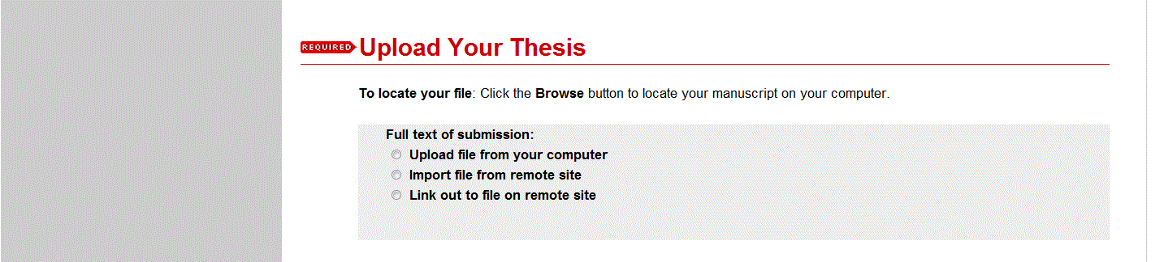
After completing the descriptive fields, you will be prompted to upload your thesis from the computer. When the form is complete, you should click the “Submit” button. Once clicked, the button text changes from “Submit” to “Processing.” If the upload succeeds, your browser will display a confirmation page. If there is a problem, you will be prompted to correct the error. The upload process may take several minutes depending on the size of the file, so please be patient.

If you need help using SCARAB, please contact Pat Webber (jwebber@bates.edu) at the
Muskie Archives

