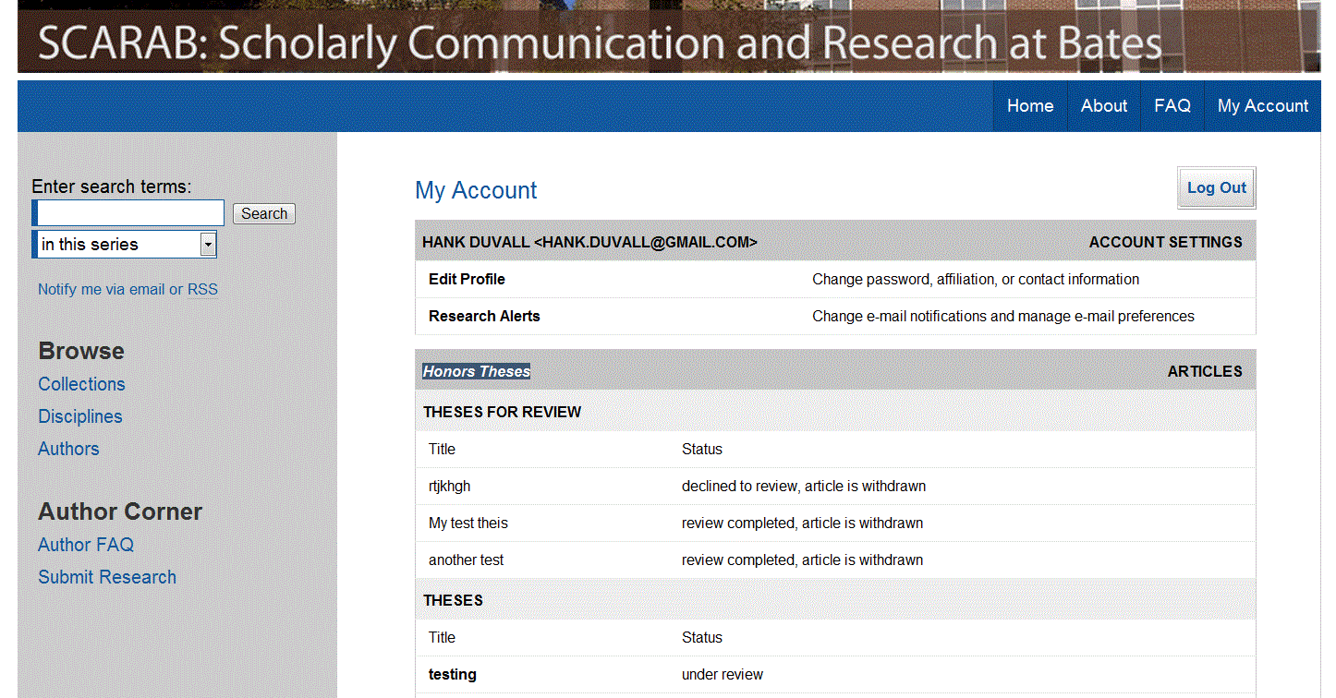
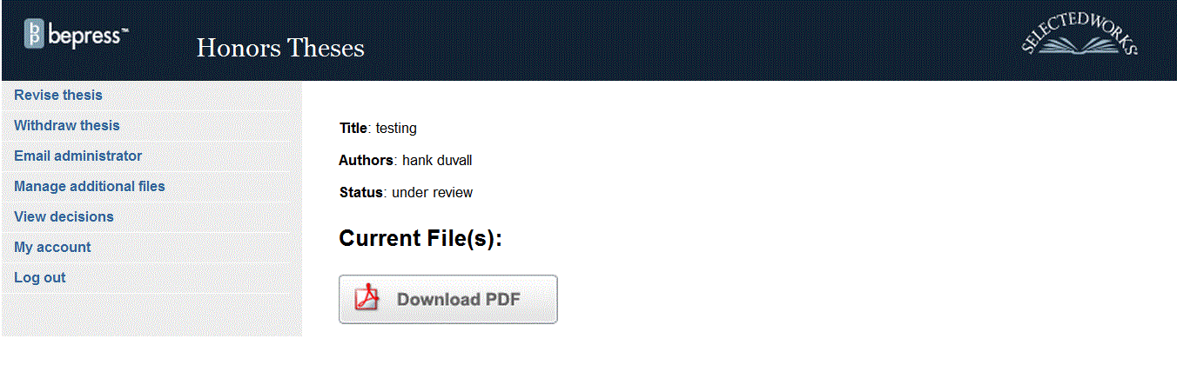
Uploading the Final Version of a Bates Honors Thesis to
SCARAB

Accessing Your Thesis

Navigate to http://scarab.bates.edu, choose “My Account”, and log in as you did when submitting your thesis.

Click on your thesis title.

To upload a revised thesis and / or correct thesis metadata, click “Revise Thesis” in the upper left-hand corner.

Review the entries on the thesis submission form and revise them if necessary:
• Thesis title (Revise if necessary)
• Author (Your name)
• Date of Graduation (Use May 30, 2015.)

• Level of Access (Select “Open Access” to make your thesis publicly available. Select “Restricted Access” to make your thesis accessible to the Bates education community only. The selection you make must match the selection you made on the Thesis Access and Embargo Form.)
• Embargo Period (If appropriate, select and enter an embargo period for your thesis. The selection you make must match the selection you made on the Thesis Access and Embargo Form. Once entered, the period of embargo cannot be changed.)
• Degree Name (Select “Bachelor of Arts” or “Bachelor of Science”)
• Department or Program (from which you received honors)
• Second Department or Program (from which you received honors, if applicable)
• Components of Thesis (If you removed or added content after the oral exam, you must update this field.)
• Advisor(s) (of the thesis)
• Keywords (six descriptive words or phrases, each separated by commas, that might help with the indexing and retrieval of the thesis; these concepts should represent the primary essence or most salient aspects of the work.)
• Abstract (Paste an updated, one paragraph thesis abstract of 250 words or less.)

After updating or confirming the descriptive fields, you will be prompted to upload the final copy of your thesis from the computer.

Things to Remember

Set the “Level of Access” you chose in consultation with your advisor. Your choice must match the choice you made on the signed “Thesis Access and Embargo” form.
• If you grant “Open Access” to your thesis, your final thesis document/zip file should not contain materials that exceed the fair use provision of the United States copyright law. See http://www.bates.edu/ils/policies/access-use/copyright-for-scarab/ for information about fair use. You should have identified and removed any such materials initially provided for the reference of your honors panel that does not comply with fair use.
Set an “Embargo Period” if you and your advisor identified one. The period must match the date provided on the “Thesis Access and Embargo” form. Once chosen, the period of embargo cannot be changed.

Once you have confirmed the information on the form, upload the new thesis file (if there is a new one) in the same way that you originally uploaded your thesis. Remember, if you have multiple files they must be bundled into a single zip file (see the Bates Help Desk for help creating a zip file).

Click “Submit” to finish the process.
If you need help using SCARAB, please contact Pat Webber (jwebber@bates.edu)

