Instructions for Year End Self Review
- Go to www.bates.edu/hr/performance.
- Click on Access Performance Development ONLINE.
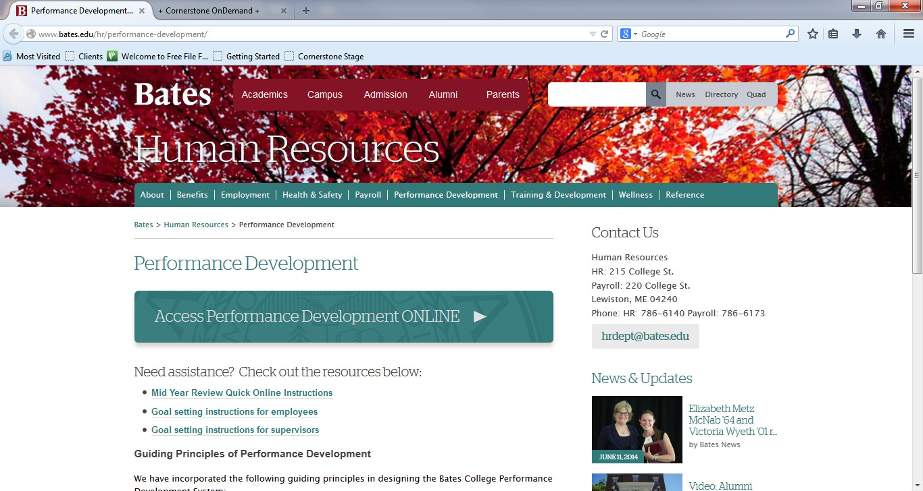

- Enter network username and password (same as e-mail).
- Click login - You will now see the Bates Performance Development Welcome Page.
- Read the Important Information and review the graphic of steps in the process.
- Click on Complete 2016 Year End Self Review in the Your Tasks box. 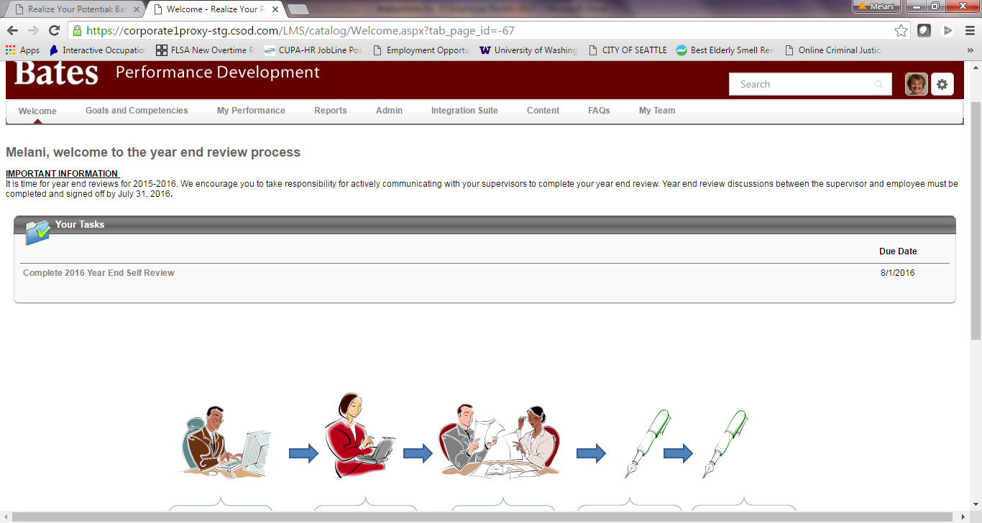

- Read the 2016 Year End Review – General Page

- Click Get Started to open the Goal and Competency Rating Section. You can also navigate to sections by clicking on the section you want in the navigation box.
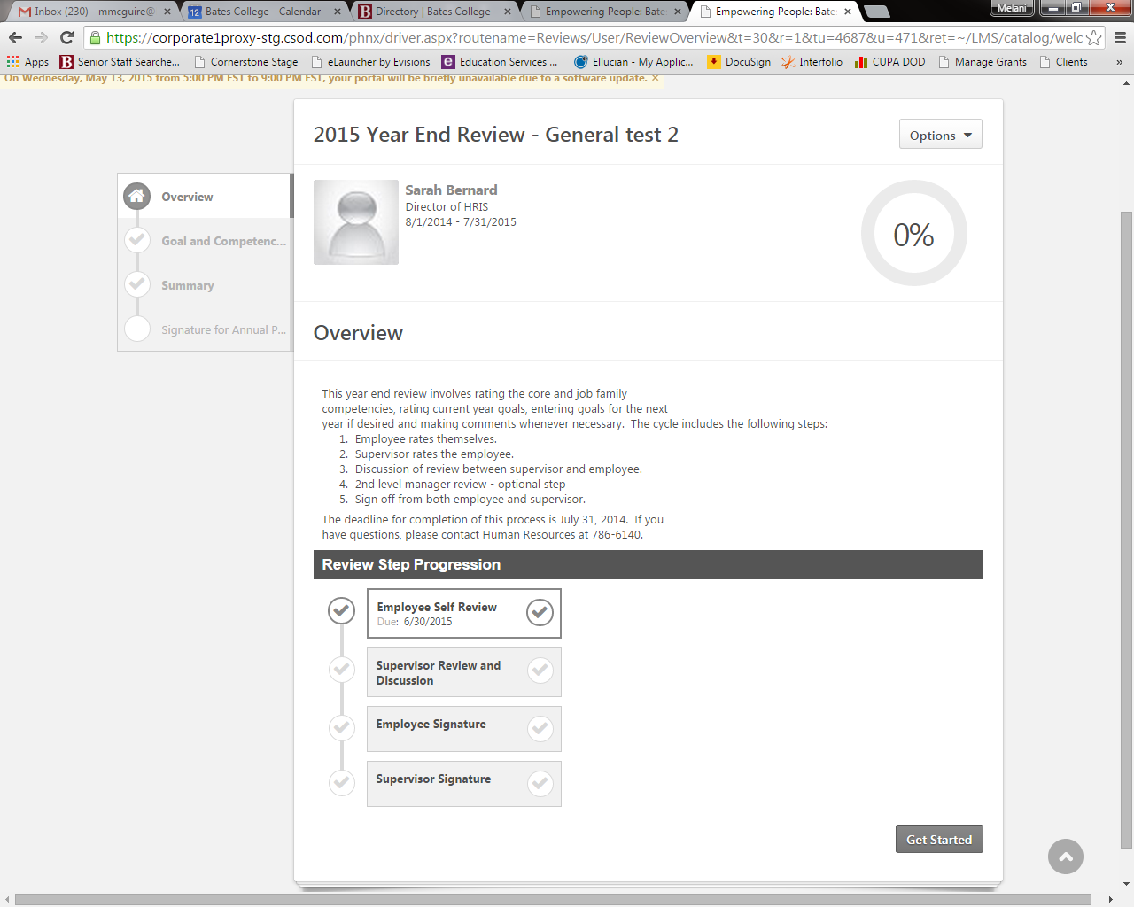

- Read the instructions directly under the Goal and Competency Rating Section title.

- Each competency and goal will have its own rating section. At the top of each section is a description, status, start and due dates of that particular goal or competency. To enter a rating, click on the Select box and a drop down list of the ratings appear. Click on the rating you want to use. A rating is required for each goal and competency. If you want to enter a comment, click in the Comments box and type in your comment.
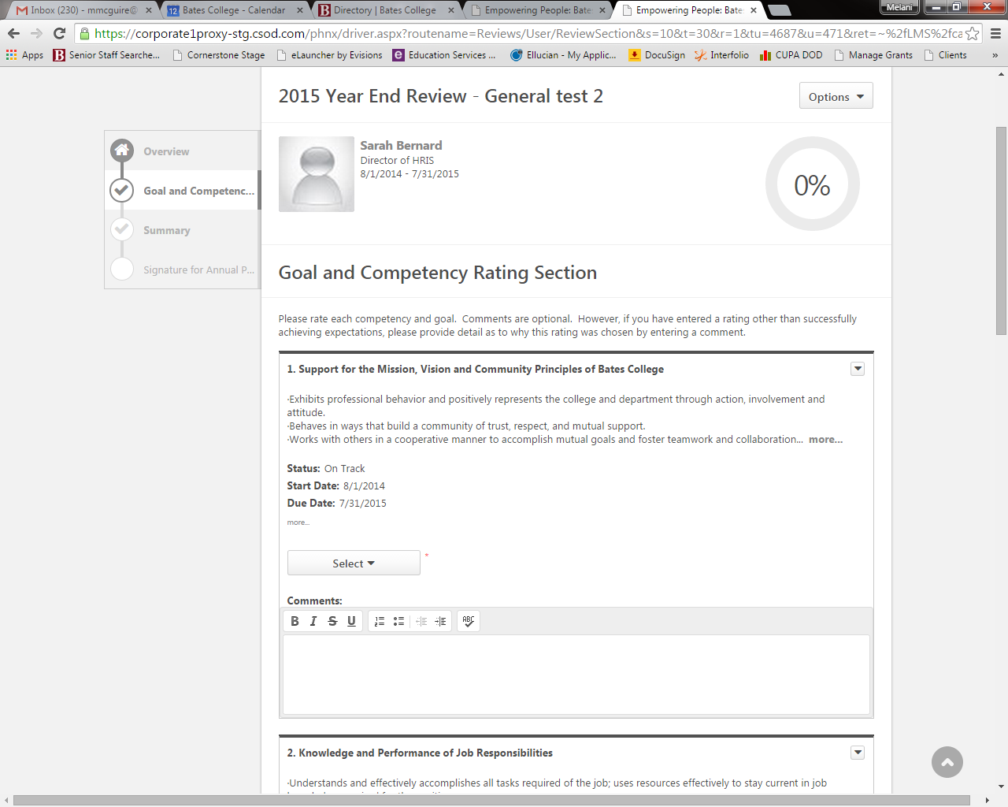

- Scroll through each competency and goal selecting ratings and entering comments. You can also add attachments to the review by clicking on the Options button and selecting Attachments.
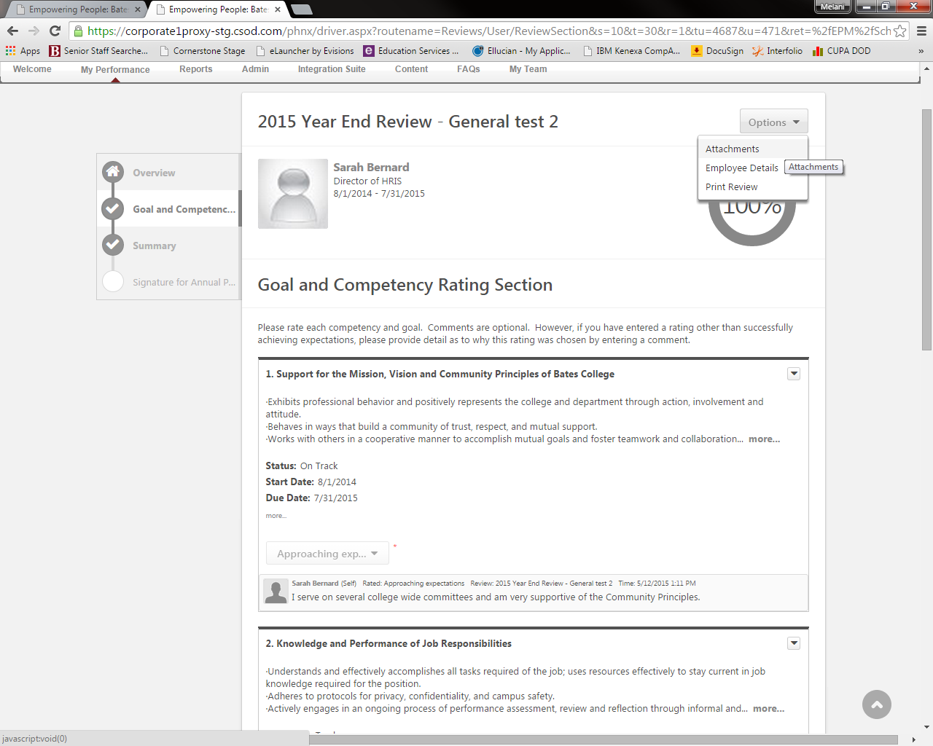

- Click on Upload up to 3 attachments.
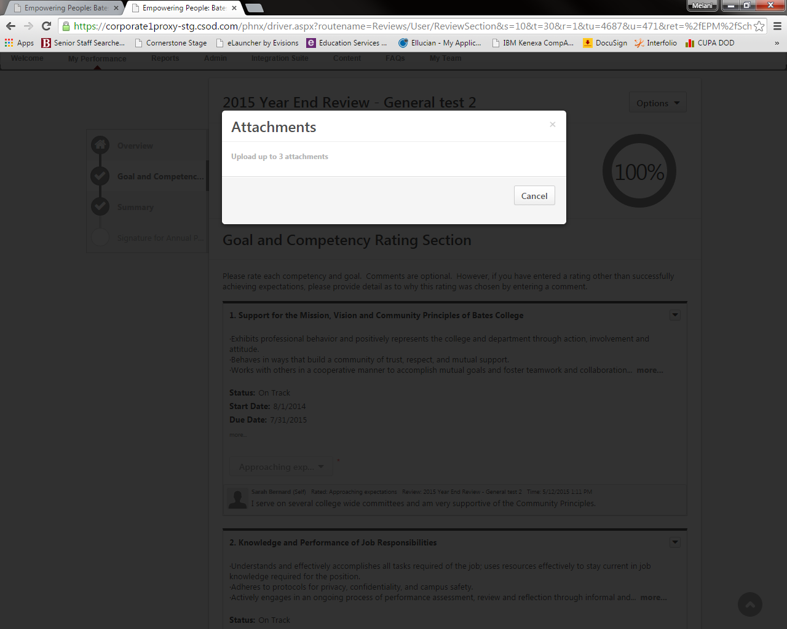

Select and Attach files as you would attach files to an email.

- When you reach the bottom you will see 4 buttons.
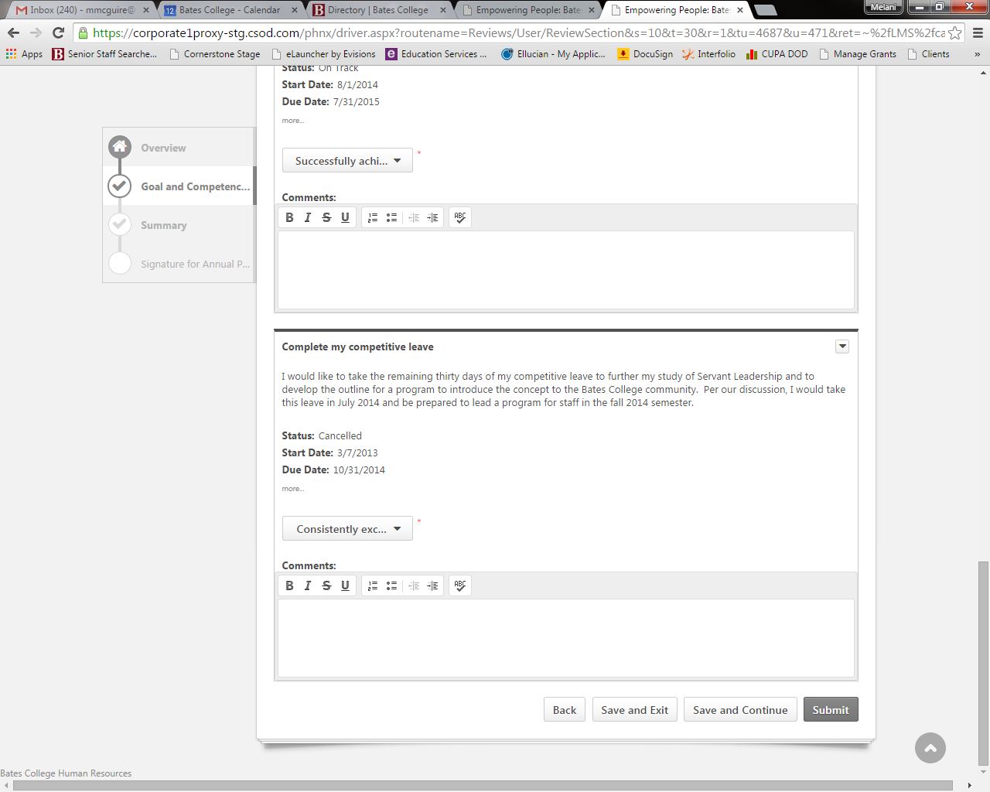
Back – will take you to the previous page. CAUTION: your work will not be saved.
Save and Exit – your work will be saved and you will exit back to the Welcome page. Use this button if you are working on your review but have not finished, but want to save your work and go back at a later time.

Save and Continue – your work will be saved and you will continue to the next page to view the overall rating summary. You can still go back or exit and return to your work at a later time.
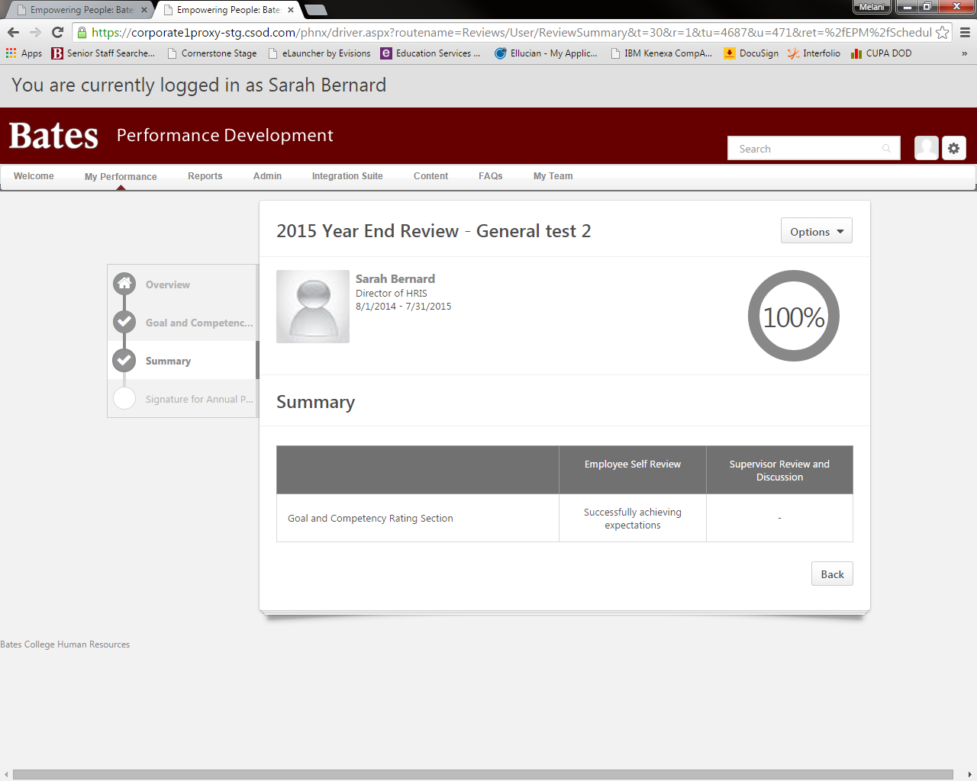
Submit – this will finalize your work and send it to your supervisor. After you click Submit a box will appear that tells you that you will not be able to modify your review once you have submitted and ask if you are sure you want to submit now. If you click Cancel it will return you to the previous page. If you click Submit you should receive a message box saying that you have successfully submitted your review. It will move your review on to your supervisor and you will no longer see it in your task box on the Welcome page.

You can still view your form from the Welcome page by clicking on the My Performance tab and then Scheduled Tasks.
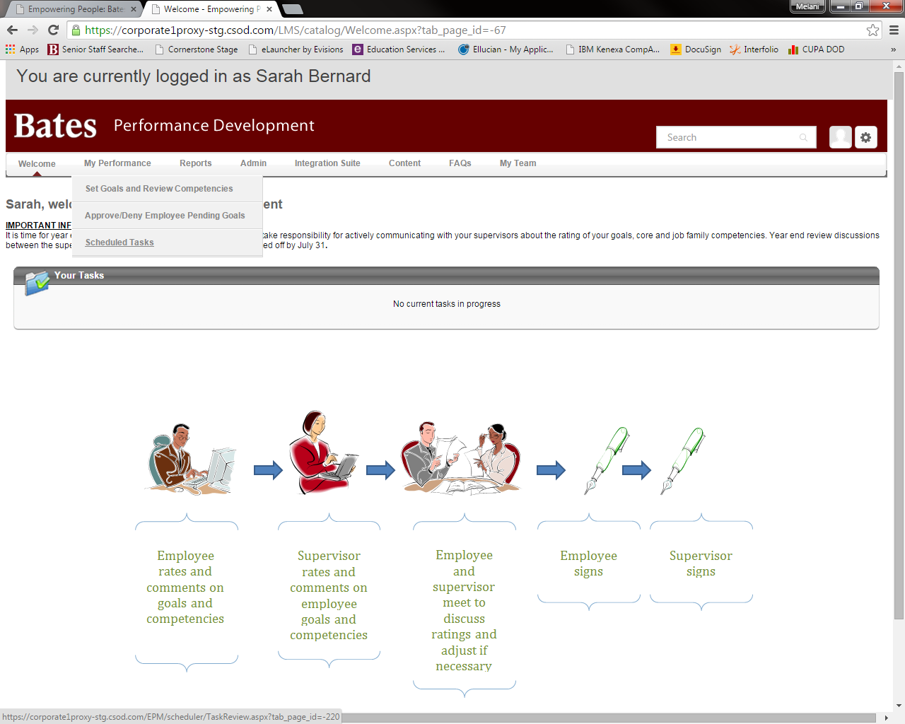

Click on the box next to Show completed and expired tasks. And the list of tasks will appear. Click on the task you would like to view.
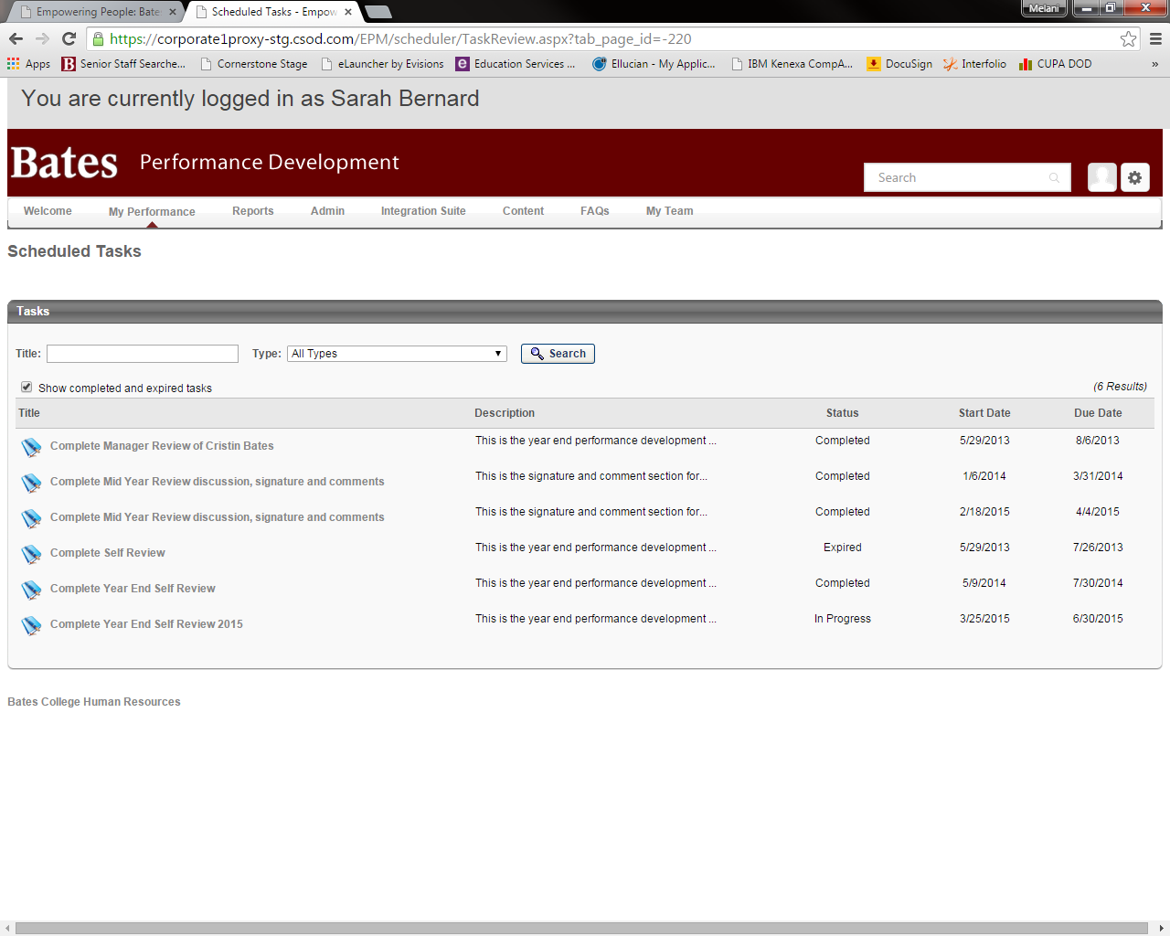

- The supervisor then enters their ratings. Once they click on Submit, you will be able to see their ratings and comments. If they keep them in draft form, your supervisor will print copies for the discussion.
- Meet with your supervisor and discuss all of the ratings and comments. The supervisor will make any adjustments to the review if necessary and then click Submit. Now the review is ready for signatures.
- To sign your review Login to performance development.

- Click on Complete Year End Self Review in your Tasks Box.
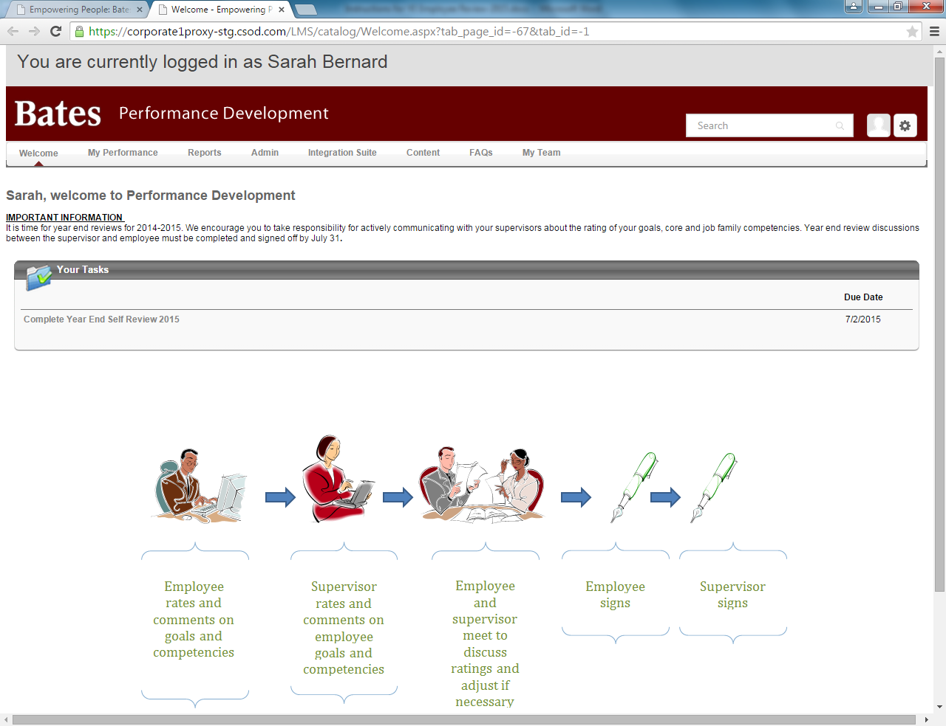

- Click on Signature for Annual Review to go directly to the signature page. If you wish to read the entire review click on Get Started and then Next at the bottom of the page until you reach the Signature page.
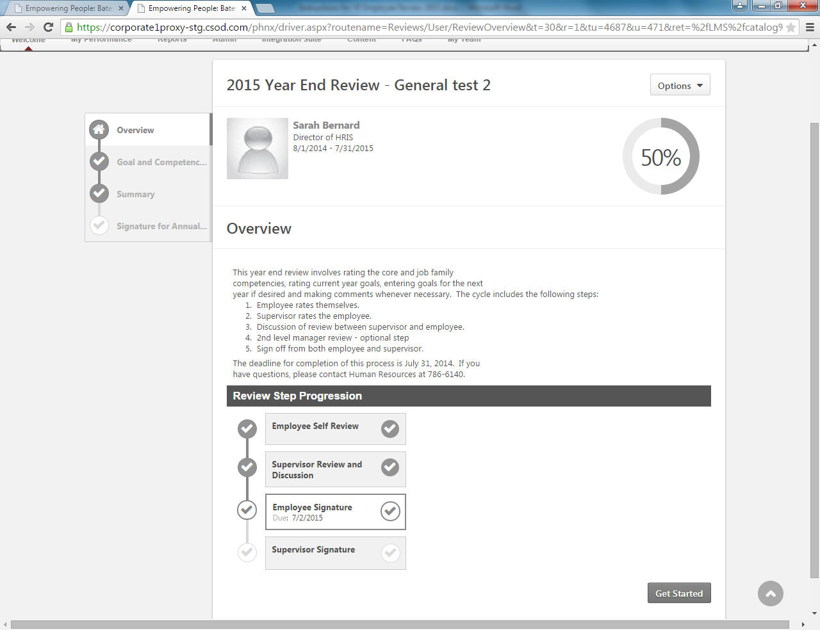

- Type your name in the box and click on the Sign button. Remember – this acknowledges that performance process and discussion have occurred. It does not constitute agreement. You are not finished yet.
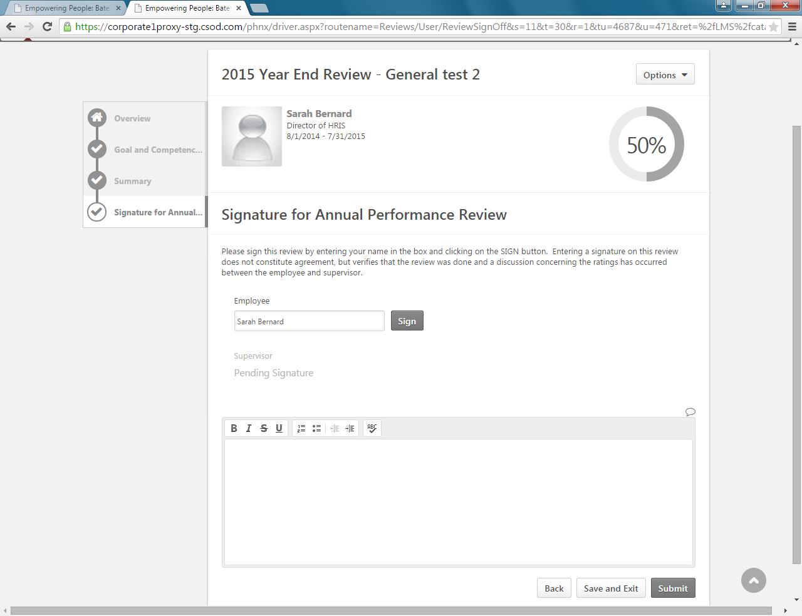

- Click on Submit. Now your form moves to your supervisor for signature.
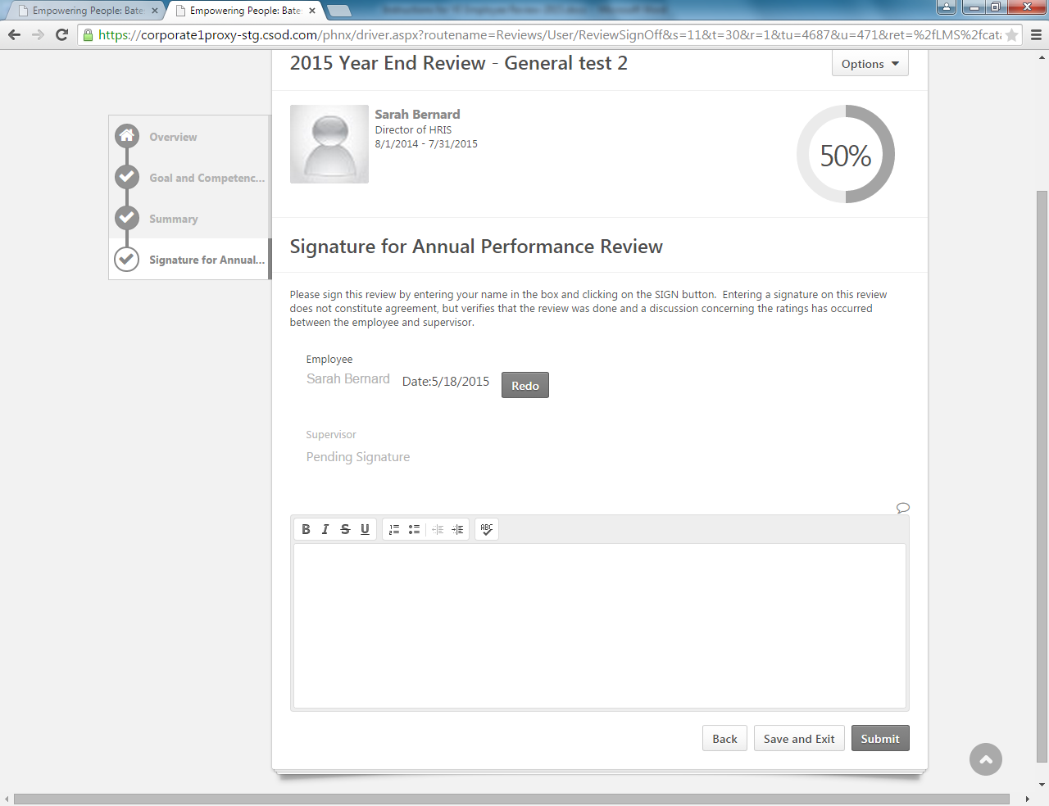

- To print your review, click on Options, then Print Review.
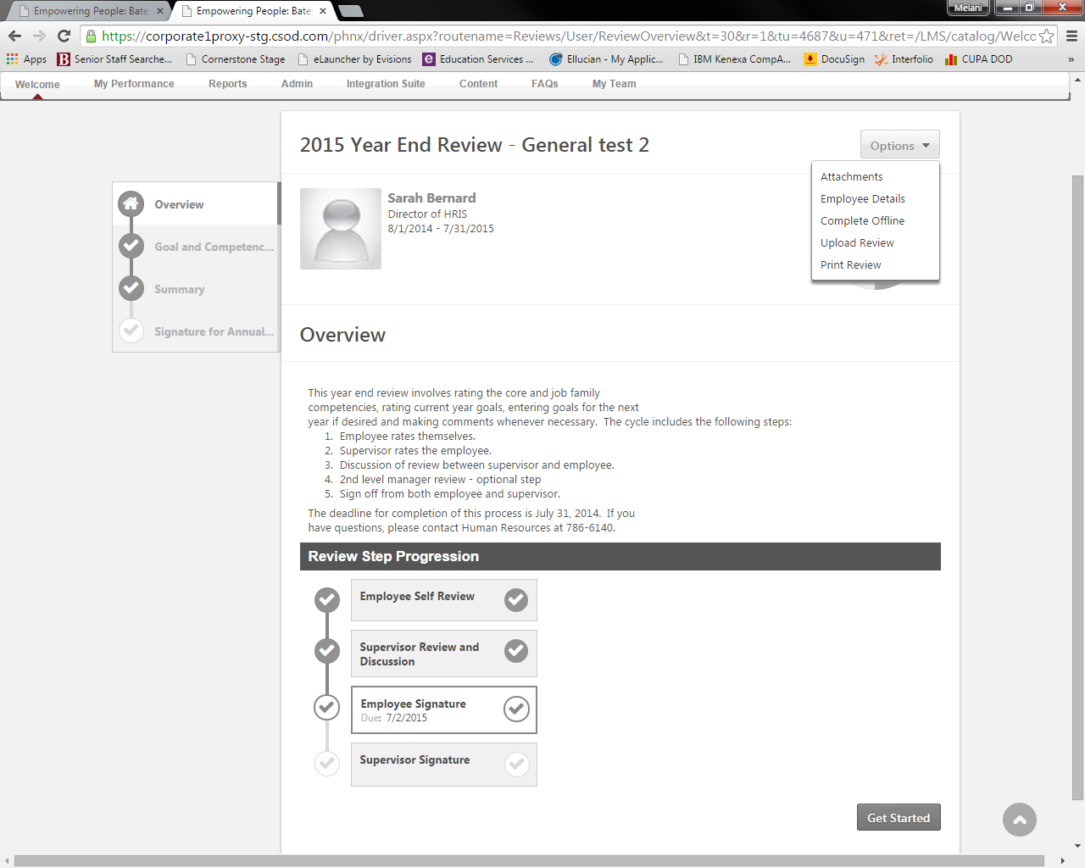

This will take a few seconds as it creates a PDF file, which may appear in the lower left corner of your screen. You can print your form or save it to your computer.
- Once your supervisor has signed and submitted your form, the process is complete. Remember, you can see your form at any time by clicking on My Performance, then Scheduled Tasks, then click the checkbox for Show completed and expired tasks.

