Instructions for Year End Self Review
- Go to www.bates.edu/hr/performance.
- Click on Access Performance Development ONLINE.
- 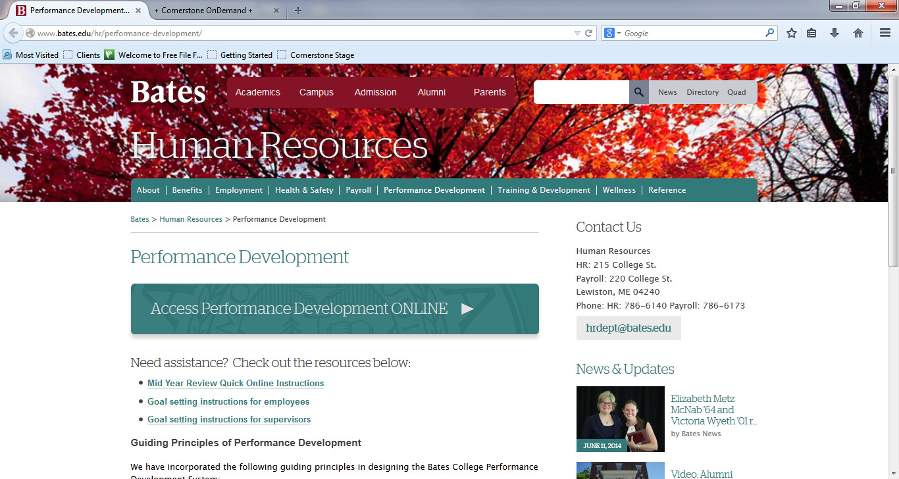

- Enter network username and password (same as e-mail).
- Click login - You will now see the Bates Performance Development Welcome Page.
- Read the Important Information.
- Click on Complete Year End Self Review in the Your Tasks box.
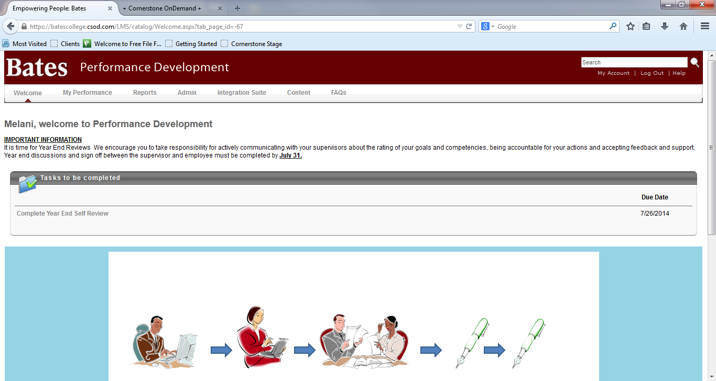
- Read the Instructions and the Review Steps.

- Click Continue to open the Goal and Competency Rating Section.
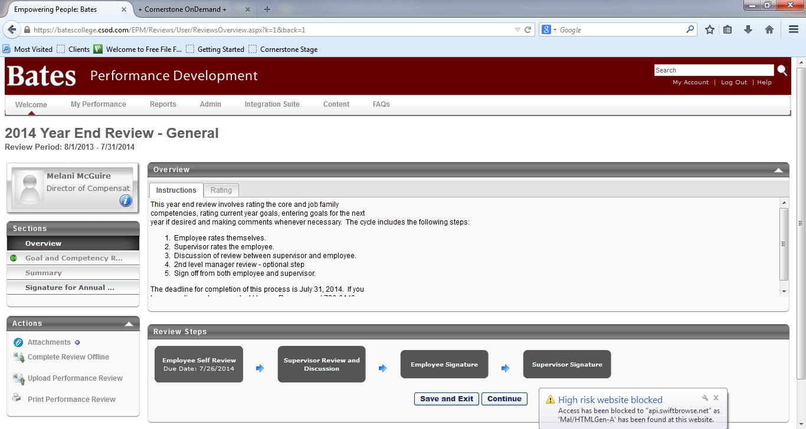

- Read the Instructions.
- Scroll through each competency and goal. You will see the description directly below the title. If you wish to see further detail, click on the down arrow next to the Due Date.
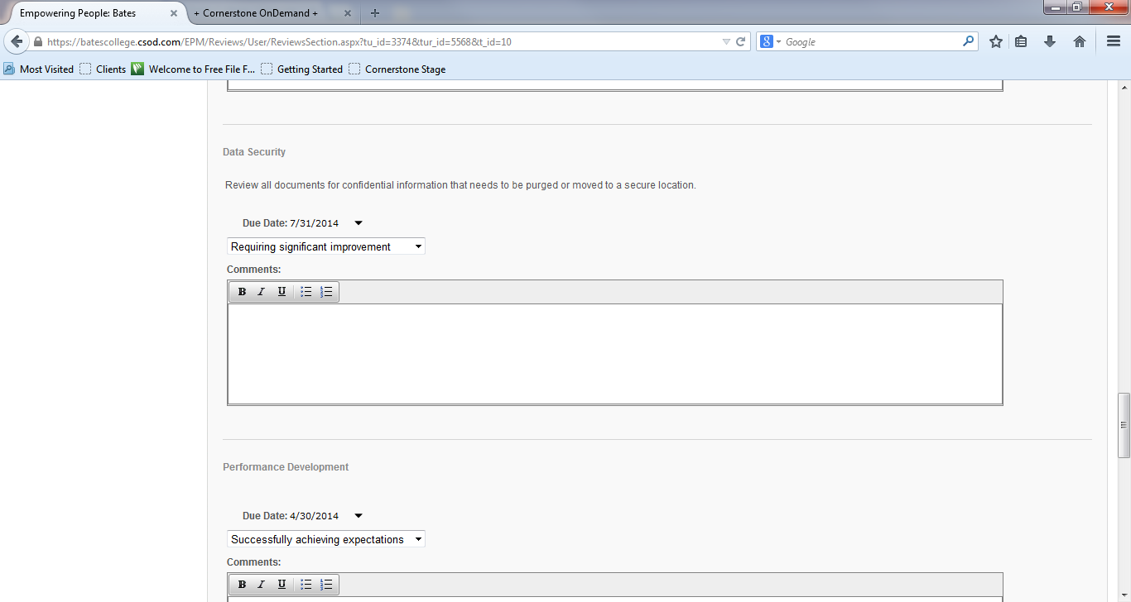

- Rate by clicking on the down arrow in the box labeled –Select—and then click on the rating you desire.
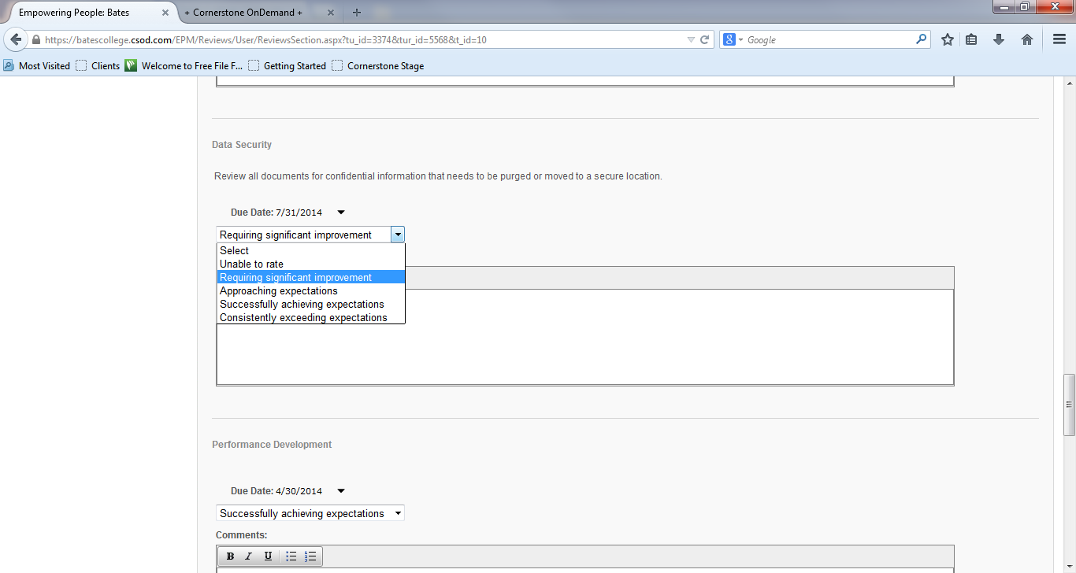

- While comments are optional, we desire that if a rating is other than Successfully Achieving Expectations, that you enter a comment to describe why you chose that rating. You can also add attachments by clicking on the Attachments + in the Actions box on the lower left. This acts like any attachment that you can browse for.
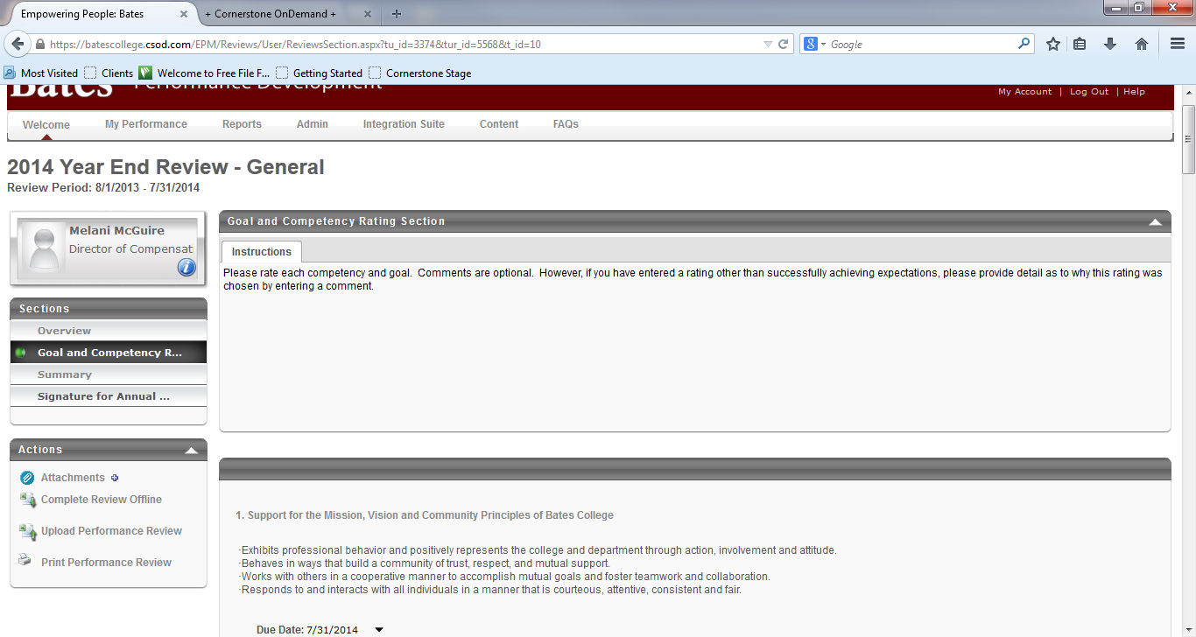

- When you have finished rating all of the competencies and goals, click on Save and Continue. You cannot leave any ratings blank.
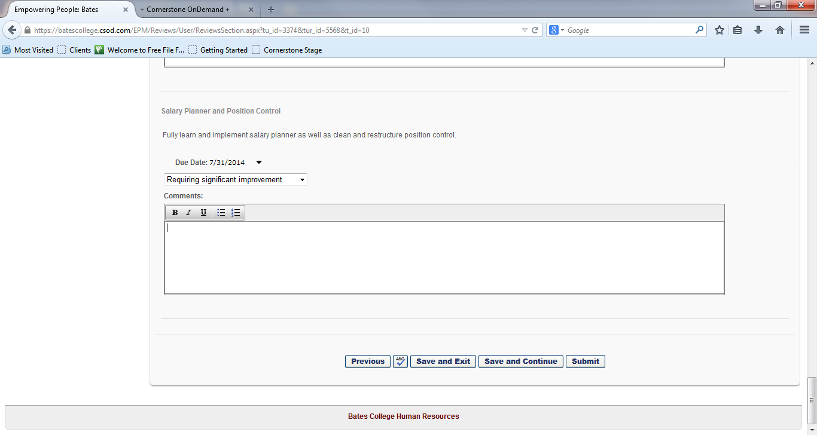

- The summary page shows your overall rating.
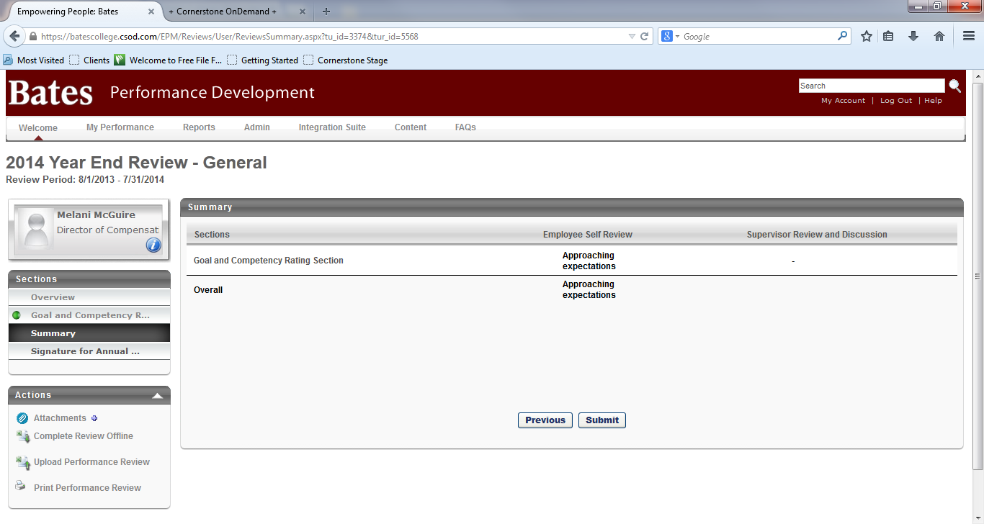
- Click Submit.
- A pop up box will give a warning and ask “Are you sure that you want to submit now?” If you are totally finished, click OK. The form automatically goes to your supervisor so that they can enter

their ratings. You no longer see the form in your tasks box. However, you can view your form by going to My Performance, then Scheduled Tasks.

Click on the box labeled Show completed and expired tasks
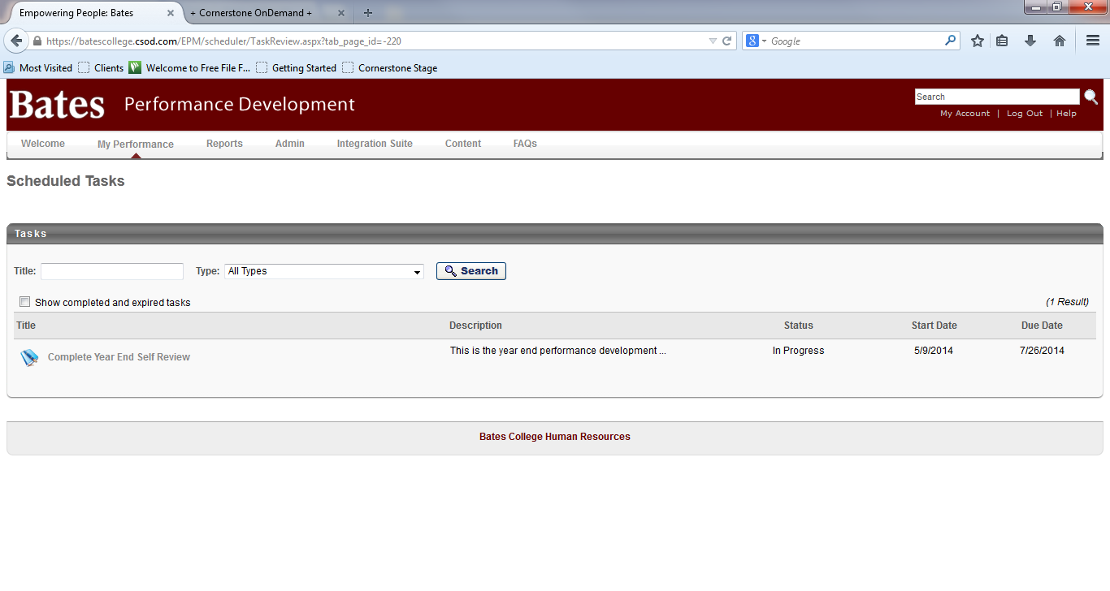

You can then click on Complete Year End Self Review with a Due Date of 07/26/2014 to see your form.
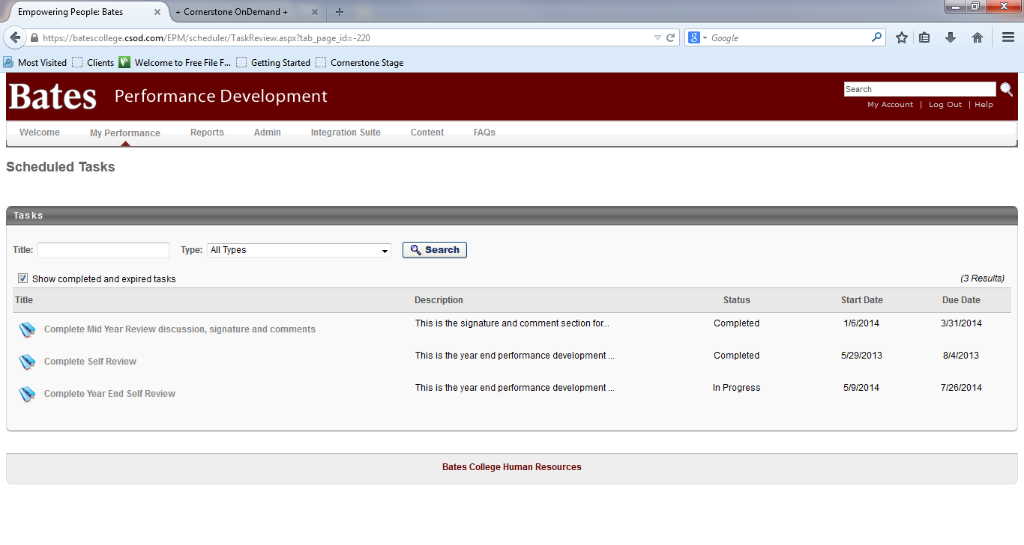
- If you are not totally finished, click Cancel, click Previous, scroll to the bottom and click Save and Exit. This enables you to go back at another time and finish your ratings.
- The supervisor then enters their ratings. Once they click on Submit, you will be able to see their ratings and comments. If they keep them in draft form, your supervisor will print copies for the discussion.
- Meet with your supervisor and discuss all of the ratings and comments. The supervisor will make any adjustments to the review if necessary and then click Submit. Note: The 2nd level manager then has the opportunity to look at the review at any time. Now the review is ready for sigantures.
- To sign your review Login to performance development.
- Click on Complete Year End Self Review in your Tasks Box.
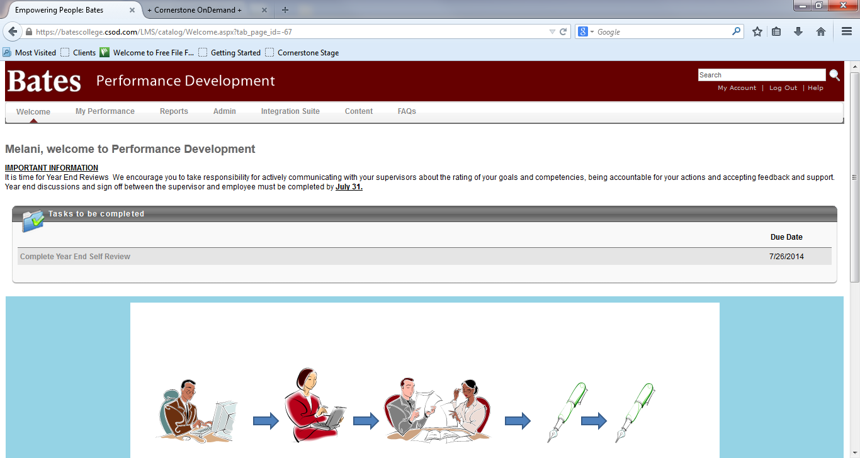

- Click on Continue or Save and Continue until you reach the signature page.
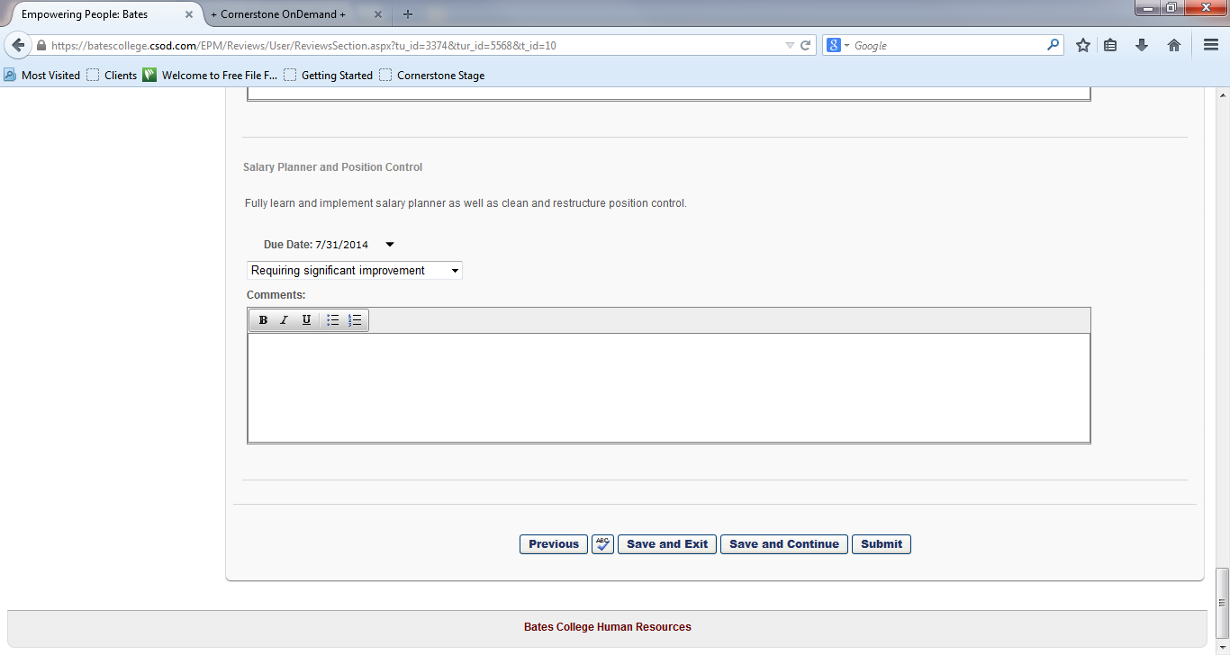
- Type your name in the box and click on the Sign button. Remember – this acknowledges that performance process and discussion have occurred. It does not constitute agreement. You are not finished yet.
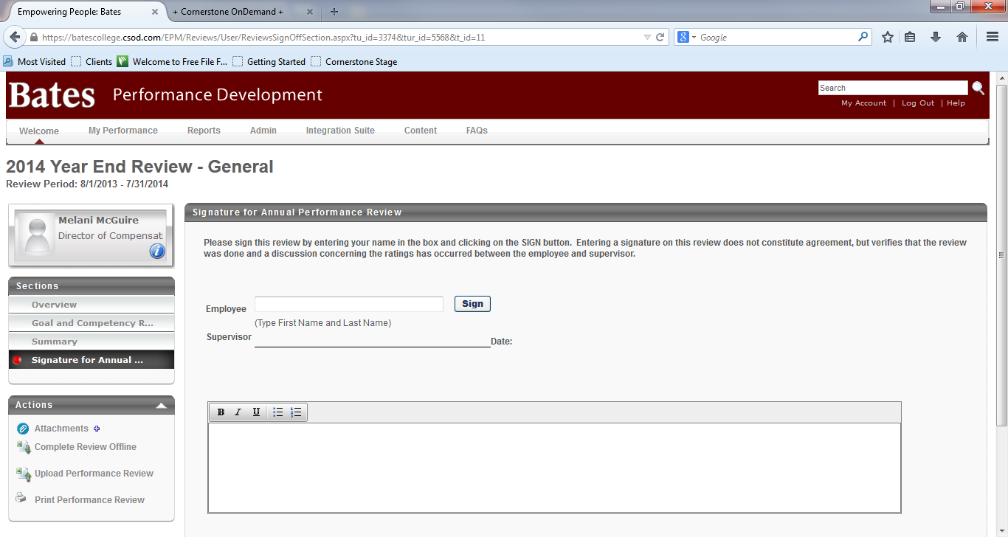

- Click on Submit. Now your form moves to your supervisor for signature.
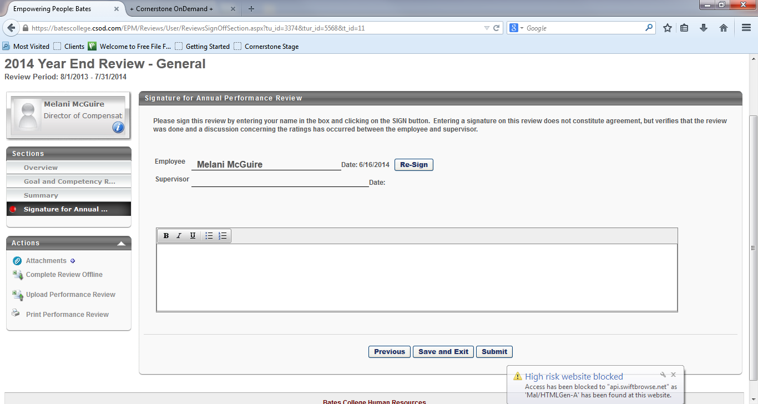

- To print your review, click on Print Performance Review in the Actions box on the lower left side.

This will take a few seconds as it creates a PDF file. You can print your form or save it to your computer.
- Once your supervisor has signed and submitted your form, the process is complete. Remember, you can see your form at any time by clicking on My Performance, then Scheduled Tasks, then click the checkbox for Show completed and expired tasks.

