BATES COMMUNITY GIVING CAMPAIGN INSTRUCTIONS

Access the Community Giving Campaign web page by selecting the Community Giving link on the Main Menu of the Garnet Gateway.

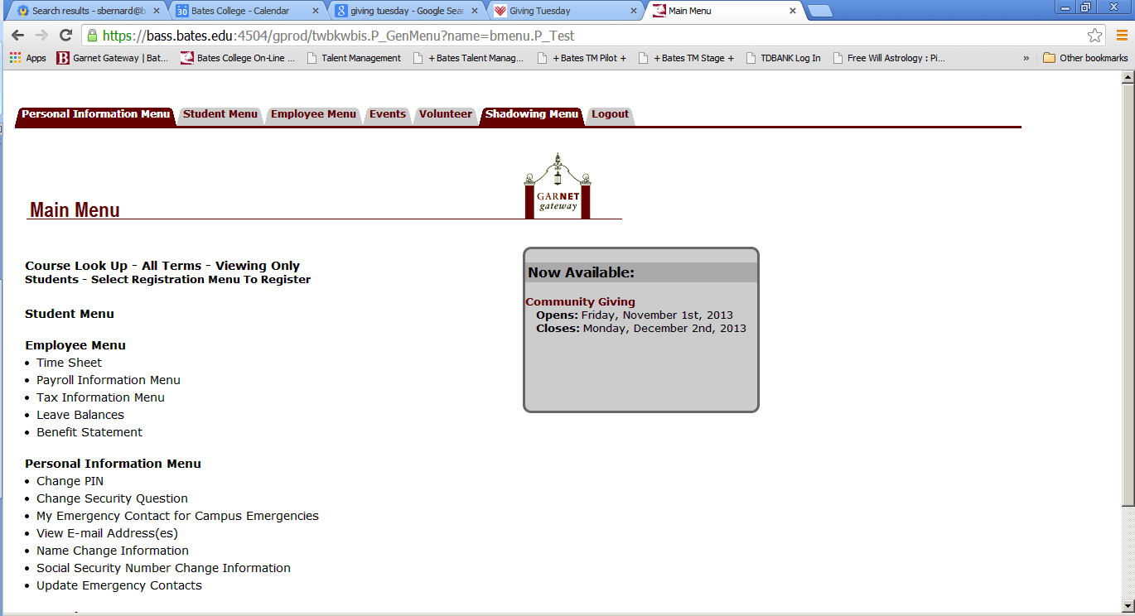

Once on the Community Giving Campaign page, enter the amount per pay period you want to contribute (the system knows how many times you are paid in a year). The choice to have a one-time deduction taken is also an option. Be sure to select either the One time gift option or the Each Pay Period option. The form will do the math for you and display your Total Gift. NOTE: one-time deductions will be taken from your first paycheck of the new calendar year (ie. first paycheck after January 1).

To the right of the Payroll Deduction box is the Recognition box. Please indicate if you wish the specific organizations you select to be notified of your gift(s) by clicking the appropriate button (Yes or No). NOTE: if you select ‘No’, you will not receive an acknowledgement of your gift for tax purposes.

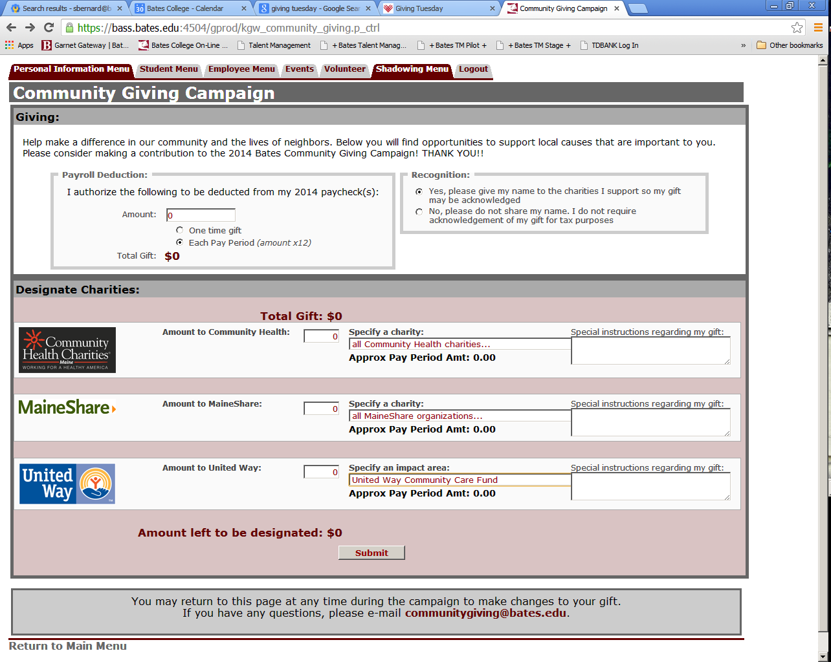

In the Designate Charities box, enter the desired distribution of your Total Gift amount. The form will calculate the approximate pay period deduction (Approx. Pay Period Amt:) based on your contribution amount and number of pay periods. If you prefer to give to one specific organization within an agency, select from the choices in the drop-down boxes by clicking on the down arrow to the right of the drop-down box. Should you need further information about any of the agencies or the organizations they support, simply click on the agency icon. A new window will pop up so that you can search for the information you need. To close the window, click “close” in the lower right corner of the box.

If you would like to split your gift between two or more organizations within an agency, list the total amount in the contribution box and then list the organizations and amount in the Special instructions box to the right. Or you may simply wish to allow the agencies to distribute your contribution as they see fit, in which case it is not necessary to make a selection.

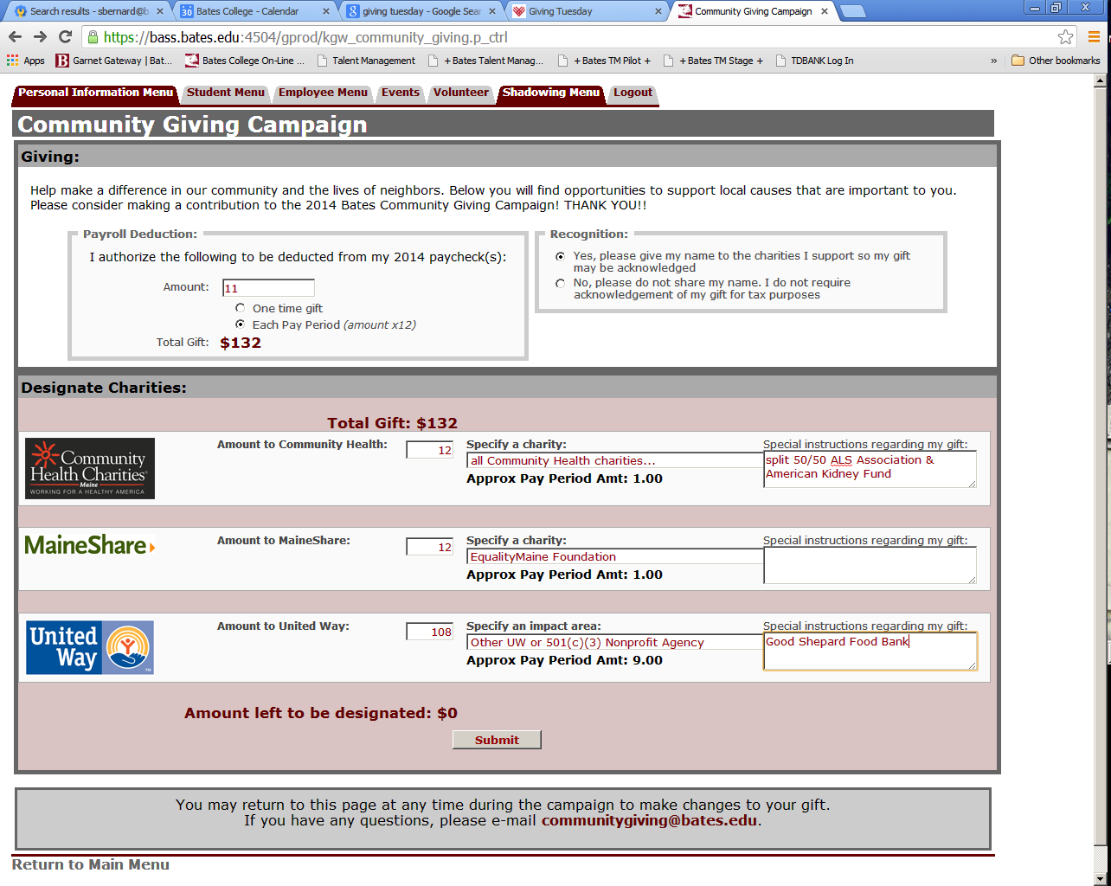

When the Amount left to be designated equals $0, you are ready to select the Submit button. Don’t forget to indicate whether or not you wish any selected charities to be notified of your name and gift.

Upon submitting your pledge, a summary page will be displayed. You will also receive an email message confirming your pledge. It is possible to revisit your pledge at any time during the campaign if you need to make any changes.

Any questions or concerns about or issues or problems with this process may be e-mailed to communitygiving@bates.edu.

