PREPARING FOR THE BRUNCH CONVERSATION:
A SOCIOCULTURAL & ETHNOLINGUISTIC IDENTITY (SEI) LETTER

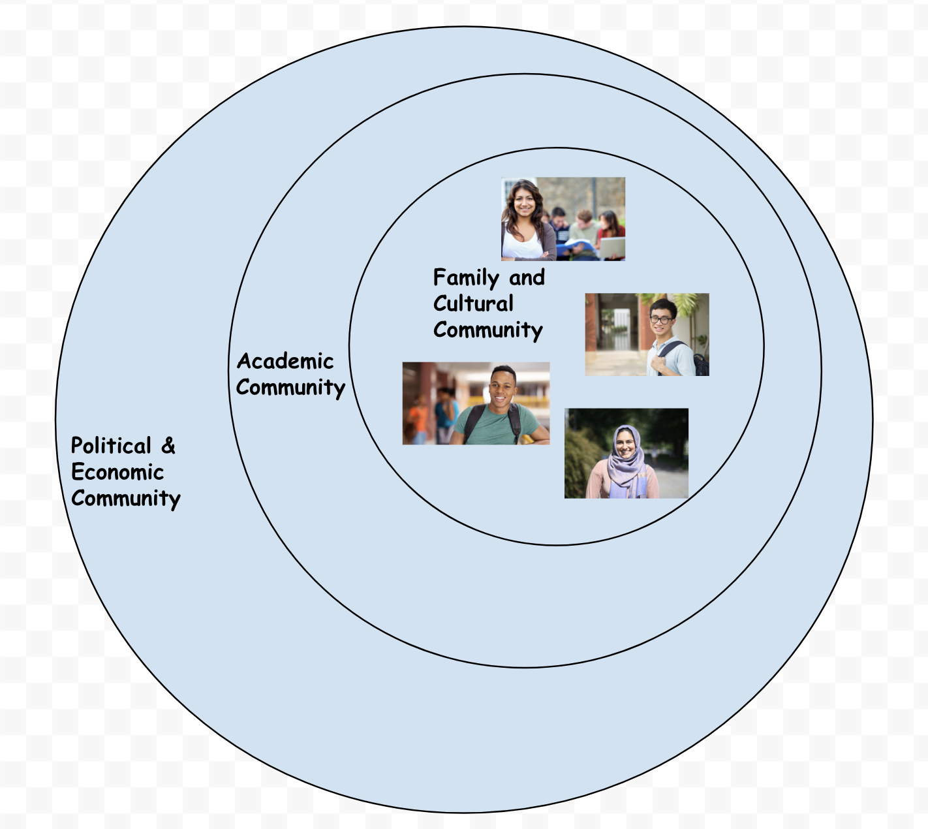
Rhetorical Task: Ask students to self-identify, or articulate their identities using narrative in the genre of friendly letter. You are the audience. The purpose of this activity is to help students identify the various cultural, social and linguistic communities that influence their identities and academic experience. It will also build rapport and encourage empathy and understanding ==you and your students and their peers. Further, it can help you get to know your students and to earn their trust so they can speak more candidly about the difficult topics that may be raised in discussions surrounding the Common Read. Students can write and/or audio or video record this as a personal letter to you. You may also write or record one for your students. Ask students to get these to you before the brunch!

Sample Question Prompts:
IDENTITY GROUPS
- What is your given name? Is there any particular significance or meaning to your name (familial, cultural, religious, other)? What name do you prefer I use in this class?
- Do you have a pronoun preference ? If so, what is it? [Options: she/her/hers; he/her/him; they/their/theirs; genderqueer; no preference; something else]
- With which continent(s), country/ies, state(s) and/or town(s) do you most strongly associate? [Feel free to list only where you are from, but also include any others places that have a substantial influence on your identity.] Why or how does this place--or do or these places--shape who you are?
- What language(s) do you speak? What language(s) is/are spoken in your home and/or in the community around you that have a direct influence on your identity?
- With what racial and/or ethnic and/or religious/spiritual group(s) do you most strongly identify and/or associate with?
REFLECTING ON IDENTITY GROUPS
- How do these identity groups influence your academic experience?
- What’s great about being a member of this/these identity group/s?
- What’s tough about it?
- What do you wish people knew about this group?
- What do you want people to never do, say, or think again about your group?
- What identity groups are you curious to know more about? In what ways?

FAMILY, WORK, EDUCATION
- Describe your connection to your family and how they have influenced your decision to come to Bates and/or to take this course.
- Do you have any outside community, military, work, or family obligations or commitments that may challenge your academic performance in this course and that I should be aware of?
- Do you have any particular learning preferences? In other words, how do you best learn material (for example, studying alone, hearing lectures, giving presentations, getting visual/graphics, writing, doing group work, etc.)?
- Please describe any documented needs or accommodations that I should be aware of. What would it help me to know about these needs or accomodations?
- Describe how this FYS reflects your own personal values and/or interests. If it does not, describe why not. Why did you sign up for this course what do you hope to learn about in it?
- What are you hoping to gain from this course as it relates to your identity--who you are and who you wish to be? Please reference the course learning outcomes in the syllabus here. Which outcomes/goals are most compelling to you? Which do you have questions or concerns about? Why?
- Finally, is there anything else about you I should know, or any course readings or content that you would like me to cover, that would help you engage in this class and its outcomes/goals?
THE COMMON READ, QUICK RESPONSES
- What did you like most about the Common Read?
- What was your biggest takeaway from it?
- What character did you most identify with? Why?
- With what aspect of the Common Read did you most struggle with and why?
Optional Extension: As a way to set a tone for exchange, listening and openness, you might first write or record and share your own “open letter” to the class at your first FYS meeting that includes your sociocultural and ethnolinguistic identities as well as your perspectives on inclusion and your commitment to honoring your students’ diverse backgrounds, experiences and learning preferences. You may wish to suggest how your own perspectives, identities, and experiences have informed your creation of this course and its intended outcomes for students. Finally, you may also include your personal reactions to the Common Read text.

Build In Moments of Identity Reflection Later in the Course: Ask students to keep their identities in mind and to reflect on their letters when engaging with course content throughout the semester. Allow room for students’ personal interpretations of course documents, readings, problem sets and study and lab results. For example, you might always include the following questions in your assignment prompts or class discussions:

How does this [document, reading, group activity, course goal, problem set, study result, lab result, etc.] relate to your group identities and personal experiences that you shared with me at the start of the course? How does it inform, confirm, challenge, or oppose your own experiences in your family or culture?; the academic experiences you’ve had so far (i.e. in high school, in your major, in this or other courses here at Bates)?; your political or religious views?; the experiences you’ve had in your workplace(s)?
A FEW MORE RESOURCES TO PREPARE
On Creating Inclusive College Classrooms:
http://www.crlt.umich.edu/gsis/p3_1

On Making “Inclusive Moves” in Your Course:
https://bokcenter.harvard.edu/inclusive-moves

On Teaching Diversity in Your Classroom:
https://ctl.yale.edu/teaching/ideas-teaching/diversity-classroom

On Engaging in Difficult Dialogues in Higher Education:
http://www.difficultdialoguesuaa.org/handbook/landing

Managing Hot Moments in the Classroom:
https://www.cmu.edu/teaching/resources/Teaching/CourseDesign/InstructionalStrategies/HotMomentsClassroom.pdf

Guidelines for Discussing Incidents of Hate, Bias and Discrimination:
http://www.crlt.umich.edu/publinks/respondingtobias

AT THE COMMON READ BRUNCH
Having read them, offer some general feedback on the students’ Identity Letters. Honor the various identities and voices of the students in your course and be clear and upfront about your expectations for respect, fairness, equity and diversity now and throughout your course. Remind students of the Bates Mission Statement. Let them know some of the conversation today may be challenging, but this is Bates and now’s a good a time as ever to get it going. Let students know they’re safe but ask them to be open to engaging in the power of our differences!

Mission Statement
Since 1855, Bates College has been dedicated to the emancipating potential of the liberal arts. Bates educates the whole person through creative and rigorous scholarship in a collaborative residential community. With ardor and devotion — Amore ac Studio — we engage the transformative power of our differences, cultivating intellectual discovery and informed civic action. Preparing leaders sustained by a love of learning and a commitment to responsible stewardship of the wider world, Bates is a college for coming times.

Use these wonderful Discussion Questions on on Julie Lythcott-Haims’s website to guide your talk. Ask your students to preview this site and read through the questions to prepare for the discussion. In fact, every student can choose one question to facilitate the asking of or can bring their own question to ask the group. Ask your PWSA to be prepared to respond to and/or ask some of these questions, too! BTW: Those links are here if you’re not on the live doc: [https://www.julielythcotthaims.com/real-american-discussion-questions] and [https://www.julielythcotthaims.com/]

Still concerned about getting student to participate in the brunch discussion? Here’s a fun blog post and podcast with concrete ideas for fostering the full participation of all voices in a group conversation. Ask your PWSA to choose one and lead it! Full link: [https://www.cultofpedagogy.com/speaking-listening-techniques/].
OTHER FOLLOW-UP ACTIVITIES: A RHETORICAL ANALYSIS
Ask students to complete a rhetorical analysis of Real American. This is one way to get them to practice and engage with the language and values in the FYS Writing Values Rubric. They can do this alone or in groups; in written or spoken formats. You may want to have student complete this assignment in stages, with chances for peer review, a visit with their PWSA, a conference with you and multiple drafts leading to a final portfolio entry of their best version of it. The purpose of this analysis would be, eventually, for a student to make a clear argument about the text’s rhetorical success and/or its failure or shortcomings. Alternatively, they can even make this a public document, a blog, perhaps, in which they contribute to a public conversation about this text. They might consider responding to the New York Times Book Review of it online, or to write a similar review and find a sponsor that will publish it. Perhaps they could write an article for a local paper about the book. Julie Lythcott-Haims may even be open to reading and responding to these analyses!

General Summary Prompts
- What is the title of this text? When was it published? By whom?
- Who is the author of this text? What is her expertise? What makes her a credible author?
- What is one key point or issue the author is making or tackling in the text?
- What the author’s take or stance on this key point or issue?

Contextual Prompts
- What’s going on in the world, in our nation and/or even locally that makes this text and the author’s stance timely? Give some real world examples.

Rhetorical Analysis Prompts (based on Values Rubric)

NOTE: When responding to the following questions, ask students to include quotes, page numbers and allusions to the text to support their claims. Be sure to leave time to discuss the terms and concepts in this rubric, some of which may be challenging for students at first.

Writerly Self-Awareness, Confidence & Voice | - Does Lythcott-Haims take some risks in and responsibility for her topic and thesis? Where?  - What tone of voice does she use in the text? Find a few examples.  - Do you get a sense of the writer’s identity and confidence in the text? Where (or why not)?
The Writing Process | - Does Lythcott-Haims seem to have engaged in some kind of writing process in writing this text?  - If so, how do you know or what can you imagine her process was?  - Do you think she drafted and revised? Proofread and edited? Did she have help? From whom?  [These are great questions to ask HER when she comes to visit Bates on September 18!]
Critical Thinking, Metacognition and Reflection | Point to some moments in the text where Lythcott-Haims does or does not do the following:  - Make it clear that she’s made up her mind about her key point or issue and articulated how she got there.  - Demonstrates adequacy and accuracy in how she deals with the issue/key point.  - Avoids jumping to conclusions, avoids clichés, and/or interrogates unquestioned ideological or negligent perspectives in regard to the issue/key point.
Developing Ideas & Synthesizing Those Ideas with New/Others’ Ideas | Point to some moments in the text where Lythcott-Haims  - Includes, analyzes, or appropriately represents (i.e. cites) varying perspectives on the key point or issue she is tackling.  - Offers her own original perspectives on the key point or issue.  - Includes clear claims/points with related reasons to support her stance.  - Supports her reasons with reliable, credible evidence and well-chosen examples.  - What kinds of sources does Lythcott-Haims use for support?
Awareness of Genre & Language Conventions | - What genre is this text?  - What are some of the conventions of this genre, particularly in regards to style and language? Does this text “sound” similar to others in its genre?  - What about form, content and organization? Does this text “look” similar to others in its genre?  - What is usually “off limits” or not a common convention of this genre?  - Where does Lythcott-Haims stay within the conventions of this genre? When or where does she break with its conventions? Why does she do this - to what effect?
Awareness of Audience, Sense of Purpose for Texts (Even Beyond the Classroom) | - Who is the intended audience for this text? How do you know?  - What, do you think, is Lythcott-Haims trying to do to her audience with this text? What is her rhetorical purpose?  - How does she use the rhetorical appeals of ethos (credibility/character), pathos (emotion) and logos (logic) to fulfill her purpose and reach her audience?  - Find some responses to the text from different kinds of audiences or readers. What are others saying about this text?  - What does Lythcott-Haims herself say about the book? Find examples online.
Connecting With & Getting to Know a Writer | - In what ways have you been moved, touched or otherwise informed about some aspect of the Lythcott-Haims’s life, beliefs and/or culture in reading this text?

Take a Final Stance
Choose one overarching key point to make about the rhetorical success and/or failure or shortcoming of Lythcott-Haims’s Real American. In other words, take a final, sweeping stance on this text, something akin to a thesis statement. In what ways, do you think, do the text and author finally accomplish their rhetorical purpose and speak to their intended audience AND/OR in what ways does the text and author fail or fall short?

MORE FOLLOW UP: SOME CREATIVE WRITING ACTIVITIES
Timeline:
- Make a timeline of the events in Julie Lythcott-Haims’s life.
- Make a timeline with other events that occurred during her life--political, cultural, social, economic.
- Which events does she mention? Which other events seem related to her experiences?

- Make a timeline of events in your own life.
- Make a timeline with other events that occurred during your life--political, cultural, social, economic.
- Which events do you mention? Which other events seem related to your experiences?

- What do these timelines suggest about the relationships between our lives and other events?

Maps:
- Create a map of places that are important in Lythcott-Haims’s story. Select one or more places to study. Write/talk about the relationships between place and identity and experience.
- Create a map of places that are important in your life. Select one or more places to study. Write/talk about the relationships between place and identity and experience.

Family
- On page 7, Lythcott-Haims traces her family history to her great-great-great-great grandmother. Who was your great-great-great-great grandmother? Great-great-great-great grandfather? (Or go back as far as you can). Learn about these people. Create a class blog about your ancestors.

Objects
- On page 22 and 27 and elsewhere, Lythcott-Haims describes books and objects from her childhood home. Why are these significant?
- Pick an object (or more) and describe its significance to you and/or your family. Research the object. As a class, create a digital cabinet of wonders to display your objects and annotations.

Turn Your Rhetorical Analysis Into A Memoir
- Review the conventions and elements of the genre of memoir and how Lythcott-Haims carries out those conventions in her book. Craft a personal narrative or memoir in which you practice using some of the same conventions in your own writing. Write a cover memo in which you analyze the choices you made in writing your memoir in relationship to your purpose and what you learned from reading Real American.

Allusions/Connections to Other Texts
- On page 182, Lythcott-Haims mentions her feelings about poetry and how that changed. Note the poets she mentions in the book: Nikki Giovanni, Ntozake Shange, Lucille Clifton, Walt Whitman, Emily Dickinson. Summarize her experience. Describe your experiences reading and perhaps writing poetry. Select a poem (or another creative text--song, movie, photo, work of art) that has had a significant impact on you and explain why.

These wonderful ideas are borrowed from my Writing@Bates colleague, Stephanie Wade. Thank you, Steph!

