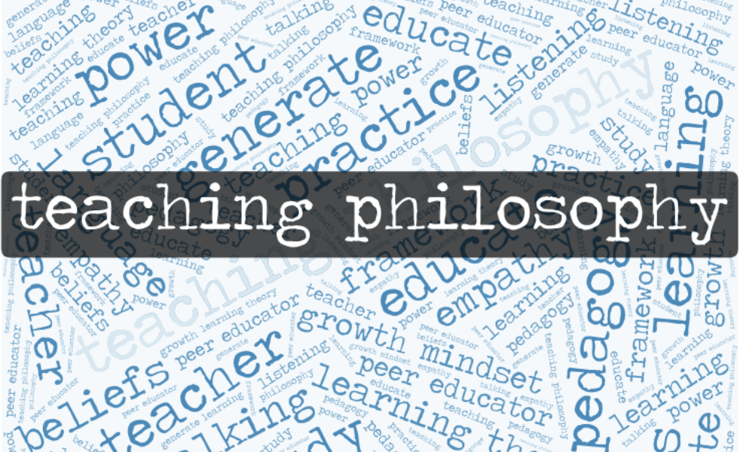

- What is a teaching philosophy?
“a purposeful and reflective essay about the author’s teaching beliefs and practices. It is an individual narrative that includes not only one’s beliefs about the teaching and learning process, but also concrete examples of the ways in which he or she enacts these beliefs…” https://cft.vanderbilt.edu/guides-sub-pages/teaching-statements/

- Why should peer educators develop teaching philosophies?
“...personal, professional, or pedagogical purposes…”
“The act of taking time to consider one’s goals, actions, and vision provides an opportunity for development that can be personally and professionally enriching. Reviewing and revising former statements of teaching philosophy can help teachers to reflect on their growth and renew their dedication to the goals and values that they hold.” ~ Nancy Van Note Chism, Professor Emerita of Education at IUPUI

Writing Prompt #1: What personal, professional, and/or pedagogical goals do you aim to achieve or have already achieved as a peer educator?

- How do we develop teaching philosophies?
  - Reflect on experiences as students and peer educators: in class and ARC, other tutoring experiences, trainings, workshops, and more.
  - Study learning theories.
  - Reflect on learning theories in relationship to experiences.
  - Draft, share, and revise. Repeat.

How do we develop teaching philosophies, continued:
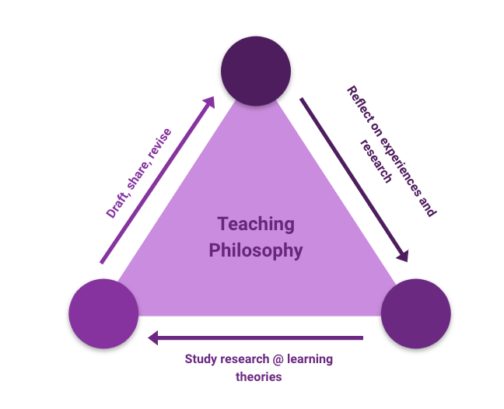

Writing Prompt #2: Why are you working in ARC? What values motivate your work?

Writing Prompt #3:
- Draw a timeline or make a list of significant moments in your own education. If you have worked as a peer educator before, includes moments from your experiences as a peer educator, too.
- Review the table of learning theories on the next page.
- Review your own experiences and begin to note correspondences between your experiences and the learning theories.
  - Note which learning theories--behaviorist, cognitive constructivist, and social constructivist--align with your most positive and most negative experiences.
  - Consider the reasons for the alignment or lack of alignment.
- Share this in your group:
  - Note which learning theories--behaviorist, cognitive constructivist, and social constructivist--align with your most positive experiences.
  - Discuss the reasons for the alignment.

NEXT STEPS: Summarize your responses to the prompts in a Google Doc, share this GoogleDoc with Eric Dyer, Bridget Fullerton, Dan Sanford, and Stephanie Wade, and post a link to it on your eportfolio.

OTHER RESOURCES

Learning Theories: “Although there are many different approaches to learning, there are three basic types of learning theory: behaviorist, cognitive constructivist, and social constructivist.” https://gsi.berkeley.edu/gsi-guide-contents/learning-theory-research/learning-overview/

 | Behaviorism | Cognitive Constructivism | Social Constructivism
View of knowledge | Knowledge is a repertoire of behavioral responses to environmental stimuli. | Knowledge systems of cognitive structures are actively constructed by learners based on pre-existing cognitive structures. | Knowledge is constructed within social contexts through interactions with a knowledge community.
View of learning | Passive absorption of a predefined body of knowledge by the learner. Promoted by repetition and positive reinforcement. | Active assimilation and accommodation of new information to existing cognitive structures. Discovery by learners is emphasized. | Integration of students into a knowledge community. Collaborative assimilation and accommodation of new information.
View of motivation | Extrinsic, involving positive and negative reinforcement. | Intrinsic; learners set their own goals and motivate themselves to learn. | Intrinsic and extrinsic. Learning goals and motives are determined both by learners and extrinsic rewards provided by the knowledge community.
Implications for Teaching | Correct behavioral responses are transmitted by the teacher and absorbed by the students. | The teacher facilitates learning by providing an environment that promotes discovery and assimilation/accommodation. | Collaborative learning is facilitated and guided by the teacher. Group work is encouraged.

- You will find more details about learning theories here: https://gsi.berkeley.edu/gsi-guide-contents/learning-theory-research/learning-overview/
- You will find resources about teaching philosophies curated by the ARC professional staff here: https://docs.google.com/document/d/1atTtRM5udWtR8VmSQLmfHll1HWU5oW7V5-ZlQxIrvQY/edit
- Future ARC trainings will help you develop your teaching philosophy.
- Reflecting on, talking about, and writing about your work as a peer educator will help you develop your teaching philosophy.
- The questions below may help you generate more material for you teaching philosophy:

Definitions and Motivations:
- How do I define peer learning or peer education?
- What motivates me to be a peer educator? Why do I peer educate?
- What do I believe or value about peer education and peer learning?
- How does my own education (major/minor, ARC trainings) and experience (work, family, religion, community, etc.) influence my peer educating?
Practice
- What pieces or parts of ARC trainings have been helpful and/or helped me grow as a peer educator? How have I brought what I’ve learned into my peer educator practice?
- How does my identity/background and my peers’ identities/backgrounds affect learning in my peer-to-peer sessions?
- How do I utilize multiple pedagogical (teaching/tutoring) approaches in my peer educating?
- What are the challenges of peer education (for me)? How have I faced these challenges?
Outcomes
- What do I expect the outcomes of my peer educating to be?
- How do I know when I’ve peer educated successfully? How do I know a peer is learning something or gaining from my session with him/her/they? How do I evaluate or assess how I am doing as a peer educator?
- What are the benefits of peer education (for me)? How do I think it benefits my peers?
Fun
- If I had to choose a metaphor for peer education, what would it be? [Draw a version of the metaphor!]
- If I could make the perfect peer educator robot, how would it act? What would it say and do during sessions? [Draw the robot!]
- Imagine the worst kind of peer educator you can as a fairy tale character. What would this character be like, or do and say to his/her/their peers? [Draw the character.] If you were this peer educator’s fairy god-parent, how would you suggest the character change to improve his/her/their relations and support of peers.

