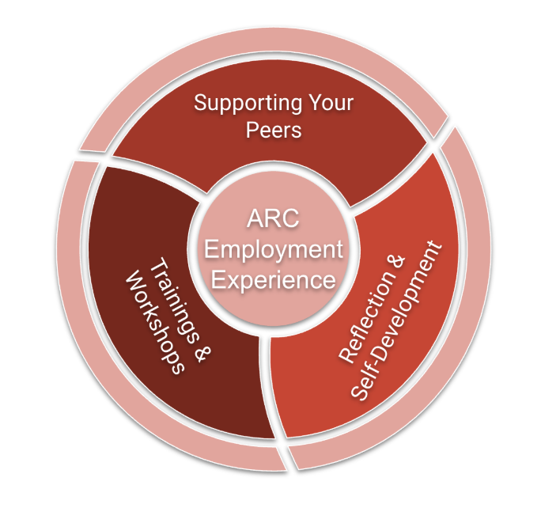
GENERAL DESCRIPTION: The ARC electronic portfolio, or e-portfolio, is a tool—an online repository—that ARC peer educators use to curate and highlight their support work with students as well as to reflect on their professional and personal growth as an ARC tutor. ARCers begin their e-portfolios during their first semester of employment and return to various aspects of them often throughout all of their semesters working in ARC. The e-portfolio is the North Star of a tutor’s ARC experience: a point to which they will often return because it is where they consistently reflect on and articulate their core values and showcase their best qualities and key resources as a peer educator to the Writing@Bates staff, to each other, and to the students and faculty they support. It is where ARC peer educators distill and connect ARC trainings and their work with students and exists as the praxis of the ARC experience where peer educators move from simply describing their growth and learning to more creatively and critically reflecting on their tutoring practices by bringing their whole self into the ARC mosaic as a more empathetic and skilled peer educator.
PURPOSE: The ARC e-portfolio exists
- to help you improve as a peer educator through visible, consistent and supported critical and creative self-reflection;
- to offer you a space to curate an online peer educator identity that showcases your values, resources and successes as a tutor and to integrate theory with your tutoring practice;
- to encourage you to engage in twenty-first century technologies and improve your digital literacy, and to help your peers do the same; and
- to share with tutors that are new to ARC and use as a training and support tool for them.
OUTCOMES: In building and completing an ARC e-Portfolio over several semesters, ARC tutors will
- define, explain and discuss key concepts and theories in peer education and writing center and/or academic support work;
- demonstrate an understanding of those concepts and theories by applying them to their own unique work experiences in ARC;
- analyze and evaluate their effectiveness as a peer educator through dialogic, critical and creative reflections on ARC trainings and workshops and on the various support sessions in which they engage with students; and
- construct an online tutor identity that showcases their unique characteristics, resources and approaches as peer educators and that includes a thoughtfully authored—and thoroughly revised—Peer Educator Philosophy and ARC Public Project that integrates key concepts, theories and tutoring practices they have enacted throughout their time in ARC.
AUDIENCE: The most immediate audience for your e-portfolio is yourself. However, the Writing@Bates staff is also a target audience as we will access and read them at various times throughout your ARC employment, offering you feedback and ideas for improvement or growth; e-portfolios are also a consideration in hiring and promotion. You will be encouraged to share your e-portfolio with your peers (i.e. other peer educators) as well as the students and faculty you support. Future audiences may include the wider Bates community, employers and graduate schools.

MODE, MEDIUM, MEDIA FORMAT: An e-portfolio offers you an opportunity to use any of the modes of persuasion you have at your disposal in an electronic, online environment. In developing your e-portfolio, you will want to consider how to use the appropriate linguistic modes (i.e. words and text), visual modes (i.e. graphics and pictures), aural modes (i.e, sound, audio), spatial modes (i.e. white space, headers, margins, fonts, etc.) and gestural modes (i.e. sign or body language, video, etc.) to suit your particular purpose(s) and to engage your target audience(s). At this time, we can support you in using AdobeSpark, GoogleSites, Wix or Wordpress to create your e-portfolio.
TIMEFRAME: We hope you remain a part of the ARC team for several semesters while at Bates and we will support your work on your ARC e-portfolio by guiding you through, among and between the following levels while you are with us (your growth as a tutor will not be as linear as these levels suggest; they are an intention, not an end).
Level 1: First semester (usually the fall) in ARC; e-portfolio will be launched and will primarily include reflections (both public and private) on trainings and tutoring, but may also include other optional items as you wish.
Level 2: Second semester working in ARC; during this semester you will work on crafting a Peer Educator Philosophy, continue to reflect on your practice, and add resources that you use with your tutees. You will be asked to finalize a solid draft of your Peer Educator Philosophy and showcase your e-portfolio to a few others within the ARC community by the end of semester or year; you may also include other optional items as you wish.
Level 3: Third semester working in ARC; during this semester you will continue to revise your Peer Educator Philosophy, reflect on your practice, and begin creating a unique ARC Public Project which reflects your philosophy; you may continue to add other optional items to your e-portfolio.
Level 4: This is the fourth semester working in ARC; during this semester you will finalize your Peer Educator Philosophy and ARC Public Project and showcase these and your e-portfolio to the ARC community and possibly to the wider Bates community by the end of the semester or year; further, we will help you consider how your e-portfolio can link to possible next steps in your thesis/capstone, professional life, or graduate work.
Writing Fellow (optional): All ARCers are also encouraged to take our short term course, EDU s19: Theory and Practice of Writing & Tutoring in order to earn the title of Writing Fellow; e-portfolios will be added to during the course and students who complete the course will receive a lovely certificate to post on their e-portfolio!
CONTENT: Your e-portfolio should at least include reflections. However, it eventually will include a Peer Educator Philosophy and ARC Public Project, and may include several other items related to your ARC experiences (see optional list below). We hope to see the content of your e-portfolio grow in new and exciting ways—that are relevant to/for you—throughout your years with us (the list that follows is not all-inclusive)!
Reflections (required, Levels 1-4): Your public reflections on ARC trainings must be easily linked to (by us) from your e-portfolio (create a “link to” button!). If they are in GoogleDoc form, they must be shared with the Writing@Bates contact person for your work group.
Dan: Writing Tutors, Language Tutors and Content Tutors
Eric: Resources Representatives, Learning Strategies, Public Speaking and Social Media Tutors
Stephanie: TWAs, PAL Leaders and upper-level PWSAs (supporting W2s, W3s, and other)
Bridget: PWSAs who support FYSs/W1 courses
We expect at least one written reflection entry to follow every ARC training session; more are wonderful! The private reflections you may keep to yourself (use GoogleDocs for this also), kind of like an ARC journal. When writing any reflections, however, always adhere to FERPA regulations in regard to the identities and privacy of your clients (use pseudonyms and/or omit any information that would allow a reader to identify a faculty or student).
Peer Educator Philosophy (required, Levels 3-4): The intellectual challenge here is for you to develop a philosophy of peer education. You will do this by considering what you know about peer education, by attending ARC workshops so you learn more about peer education, by reflecting on your work in ARC and your experiences as a student and as a peer educator, and by reviewing material about education. You will publically document your teaching philosophy in 250-500 words on your e-portfolio; it will serve as the basis for your public project.
ARC Public Project (required, Levels 3-4): This is the material manifestation of your philosophy in your choice of a public form. For example, you might create a poster or a short video. Or, you might work with one of the student managers on a project that relates to your philosophy, such as contributing to a handbook for future peer educators. You will be asked to showcase your project on your e-portfolio and to the Bates public when you have completed it.
Self-Made Resources (optional): If you have created a workshop, slide presentation, video or audio clip, or handout that you often use with your students and or the faculty you support, you may wish to include it (or a link to it) on your e-portfolio as a way to highlight the wonderful work you do! Also, you can easily find it, or direct your students to it later.
Outside Links (optional): If you often refer your tutees to particularly helpful educational websites or online books or articles, you may wish to curate a list of the URLs (links) to those items on your e-portfolio so you don’t have to always be searching for them; and to showcase the important research you do in your work as a peer educator.
Expertise and Accolades (optional): You may wish to briefly note or list your accomplishments, trainings and expertise that are particularly relevant to what you do in ARC. Posting an entire resume will likely not be relevant and may even overwhelm a student or faculty who is interested in working with you, but any information that may help tutees (and faculty) understand and trust your particular tutoring skills and/or experience in a certain major, minor or program could be very helpful to them.
Special Interest Items (optional): Create another level of connection for your tutees by posting a few unique—and perhaps non-tutoring-related items—on your e-portfolio. Are you a bird hobbyist? Do you draw or write poetry? Show a bit of the more personal, quirky side of yourself on your e-portfolio to connect to your students in a different way!

WIREFRAME OVERVIEW: The following offers one possible visual representation of the various components of an ARC e-portfolio. The darker blue portions represent required components.

AdobeSpark e-Portfolio

public facing
multiple public audiences
links to GoogleDocs & other resources
pictures, graphics, sounds
GoogleDocs

behind the scenes
public and private documents
only audiences you choose
keep ARC reflections here

Introduce Yourself

Links to Favorite Resources

Links to GoogleDoc Reflections

Other Creative Items

Public Docs

Private Docs

Tutoring Reflections

Other Items

Training Reflections

Peer Educator Philosophy

ARC Public Project
SAMPLES
- Ruth van Kampen, TWA and PWSA [https://spark.adobe.com/page/r2CpYBrB1UtvX/]
- Zofia Ahmad, RR Student Manager [https://spark.adobe.com/page/qOLNSZjZUnCrh/]
- More TBD...

