Department of French and Francophone Studies
Major and Minor Portfolio Requirement

In addition to satisfying the course requirements listed in the catalogue, all majors and minors submit a portfolio of their work to the French faculty at the end of their senior year (first week in short term). For minors, there is NO "soutenance" or defense, and the expectations for written work to be included are reduced. Please consult with your advisor early on about expectations.

Purpose
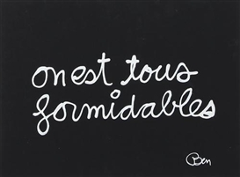
The portfolio both encourages a synthesis of a students’ work in the department, and provides an appreciation of the many ways in which their knowledge of the French language and Francophone literatures and cultures has been acquired and has proven to be transformative. It allows students to demonstrate a range of learning in multiple curricular and co-curricular experiences such as study abroad, classroom learning, work, internships, research projects, travel, writing, and performance. With the portfolio we require that students reflect upon the meaning and the trajectory of their major. After completion of the major, certain components of the portfolio are very useful in applying to graduate schools or for employment.

Procedure: Students work with an advisor as they create their portfolios. Portfolios normally include the following:

1.) A list of courses in French and relevant courses in other disciplines. Syllabi may be included, especially for courses taken outside of Bates.

2.) A personal statement, that may include (but is not limited to) a discussion of the genesis, motivation and evolution of one’s language acquisition, insights into literary texts and other forms of cultural production, and reflections upon study and experience in Francophone cultures. This personal statement should attempt to synthesize the student’s experience in French and be built around two or three inspirational quotes from French or Francophone authors or filmmakers; as a complement to these quotes, students may also select one or two inspirational or representative images (pictures, photos, or other visual icons) that help explain their experience in the major. (4-5 pages)
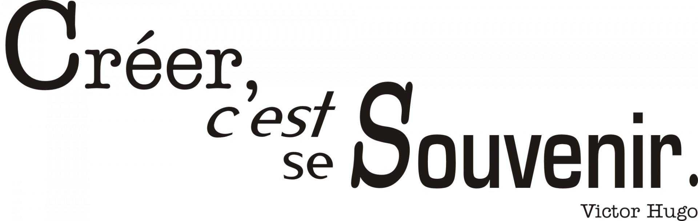

3) A representative paper that the student has written for a course during her/his tenure at Bates or abroad that demonstrates depth and breadth in the study of French. This may take the form of a thesis chapter (for majors); an essay that focuses on a particular issue or theme and studies resemblances and differences in texts from different periods (see description of the “senior essay” that may serve this purpose); it could also be selections from francophone interview project (see description of theses and the “oral history project”).

4) A minimum of three additional papers written during the student’s course work at Bates or elsewhere. A creative piece is welcome. One should not be embarrassed to choose earlier work as well as later in order to show progress over the course of the past four years. These may be submitted with professors' corrections in the state that they were returned.

Other possible material for the portfolio includes, but is not limited to: any journal or similar document written during a course, STU, or trip to a Francophone country; any of various media produced over one’s career that testify to skills in oral French, perhaps from different moments of the undergraduate experience; anything else that will enhance the student’s presentation of the major in French, such as photos, programs from performances, reports from internships, etc.

Deadlines:

For both majors and minors, the deadline is normally during the first week of short term (we will have been working ahead assiduously to meet this). For majors, the soutenance, or "defense," is within 10 days of submission. There is NO soutenance for the minor.

