French Majors 2023

Calendar 2022-2023

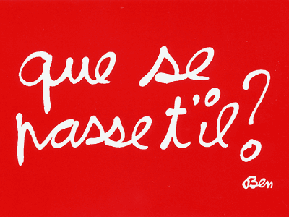

Summer-Early Fall 2022: En route!

- Be in touch with (potential) thesis advisors with regard to (potential) theses.
- Be sure that you are officially registered as a French Major.
- Begin research and conceptualizing of (potential) theses.
- If you are doing a senior essay, consult guidelines and begin crafting your question; if it will involve supplemental reading, you may wish to begin this ahead.
- If you are doing an oral history project, complete the required readings after being in touch with a professor in the department.

September 7 (Wednesday): La rentrée!

- First day of classes!
- Be sure you are registered for all classes, including thesis if you are doing one. Even as seniors, you may find that a prerequisite waiver will have to be done, especially for seminars. Contact the professor of the course directly and give them your ID number so that they can admit you. It is strongly advised that seniors take a seminar each semester, especially if they are not doing a thesis.
- MANDATORY! OBLIGATOIRE! Be in touch with your advisor about your courses from study abroad and how they will count toward your major.

September ? First Atelier de recherches
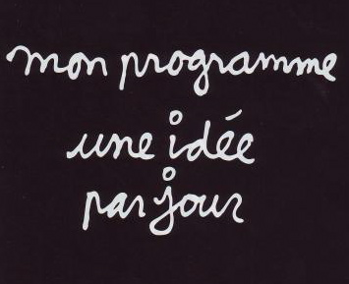
- First group meeting of majors. Getting acquainted.
- Explanation of the calendar and the road ahead.
- How to envision research in French and Francophone Studies.
- Due date for topic for Fall or two semester thesis.

October ? ( ( 413): Tales from Abroad.

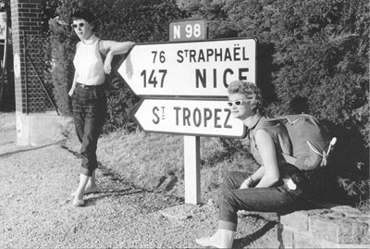

- Reception for all students returning from abroad in Francophone countries. Students contemplating study abroad are also encouraged to attend. This is a warm, welcoming and informative event. Returning students get to share their experiences and prospectives can listen in and ask questions.
- Visuals are great! If you could give digital files or photos to scan to Andrea Trumble, she can put them in a Powerpoint to help illustrate your remarks. The audience is usually fairly large and hugely appreciative.

October 19-23 (Wednesday to Sunday): Fall break.

October ?: Atelier (Noon-1pm) CV & Lettre de Motivation

October ?: Soirée crêpes chez Roger 5-7pm (Cultural Kitchen RogerW G17-18):

November 2-8: Registration Week?

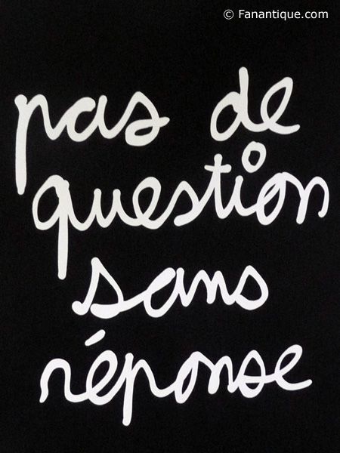

November ?: Atelier de recherches.
Thesis presentations.

November 19-27 (Saturday to Sunday): Thanksgiving break.
December ? (Friday at 6:00pm chez Kirk? Reporting in and Cooking together!

- Due date for your question for the senior essay: you will report to the group of majors on your topic or:
- Due date for your decision to do an oral history project and your plans for completion and or progress thus far, or:
- Due date for submission of your fall semester thesis (if you have elected to do this); final corrections may be made until the end of exams, December 19, or:
- Due date for your topic for a winter semester thesis (if you have elected to do this), or:
- Due date for decision of election to Honor’s Thesis (consult with advisor).
- All of this is accomplished in the festive and relaxed atmosphere of our new Cultural Kitchen and the unique occasion to cook food with your favorite professors and share their recipes! The department pays for all food and non-alcoholic drinks.

December 12-16: Final exams; first semester theses due.

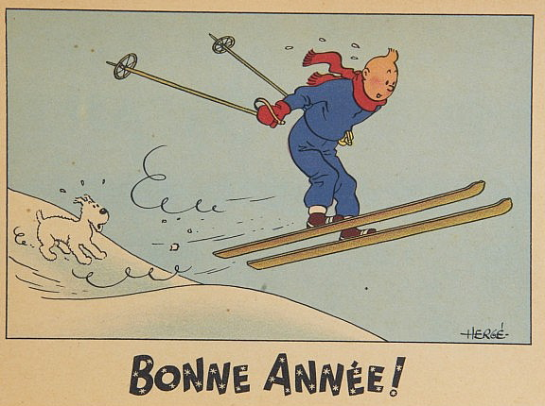

January 11, 2020 (Monday): La rentrée!

- Second semester begins. As with Fall semester, be sure you are registered for classes properly, having given your ID to professors if for some reason you do not have the prerequisites.
- Check in with your advisor some time in this first week.
- HONORS Thesis Students must consult the Honors Calendar: the dates are different from the regular thesis calendar and provide two options for submission and defense with outside examiners.
January 16 (Monday): Martin Luther King, Jr. Day

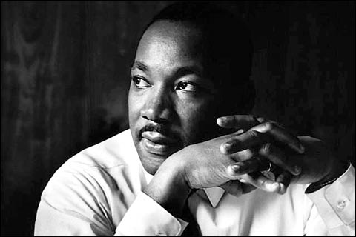

- Possible panels by students and/or faculty in French. This is a wonderful opportunity to propose workshops (performances, papers, discussions, posters) on issues of civil rights in the francophone world. Great organizing and speaking experience (in English!); great résumé line.

January ?: Atelier de recherches.
- Op-Ed Letter of Support

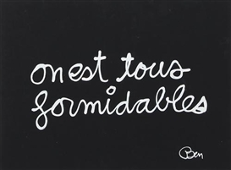

February 18-26 (Saturday-Sunday): February Recess

February ? (?, Cultural Kitchen): Atelier de recherches. Portfolio

- Come with one possible quote and one photo (personal or not) for your personal essay and portfolio. Be ready to comment critically your choice and its relevance in regard to your personal trajectory in FFS.

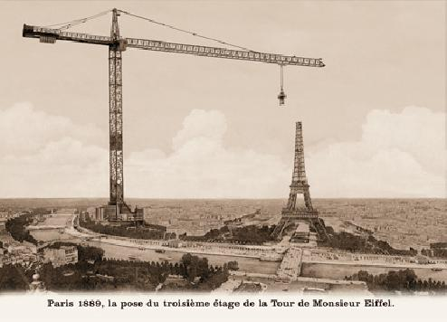
March ? (Tuesday, Noon, New Commons 201): Atelier de recherches. Reports/works in progress; FIRST DRAFT OF PERSONAL STATEMENT (Déclaration personnelle) FOR PORTFOLIO DUE.

April ? (Friday): Mount David Summit

- A wonderful chance to present your research and get feedback.
- Required of Oral History Projects.
- Highly recommended for all others.

April 14 (Friday): Last day of class!

- Last class; due date for one and two semester theses.

April ? (Thursday, Roger Williams 4th floor/French lounge): Soutenance du portfolio:

- This is a 15-minute discussion in French with all members of the French faculty about your portfolio. It is a congenial, informative and exploratory experience regarding your trajectory in French as you have presented it in your portfolio.

May 1 (Monday) - May 24 (Wednesday): Short Term

May 5 ? (Friday at 5:00pm): Portfolios Due! (end of first week of short term)

- Due date for your portfolio (and your senior essay, which must be included if you have elected this option). Please hand this in by end of day to one of your professors in French.
- This date is final and unchangeable. Work in advance.

May 12 (Friday, Roger Williams 4th floor/French lounge): Soutenance du portfolio:

- This is a 15-minute discussion in French with all members of the French faculty about your portfolio. It is a congenial, informative and exploratory experience regarding your trajectory in French as you have presented it in your portfolio.

May 26 (Thursday)- May 28 (Sunday) Commencement Weekend

May 26 (Thursday) 4:45pm, Roger Williams Fourth Floor: Department Reception for French Majors
- The French and Francophone Studies Department's traditional “kirs and tears”: toasts, small gifts, bons mots and a group photo before the final conflagration of graduation. .

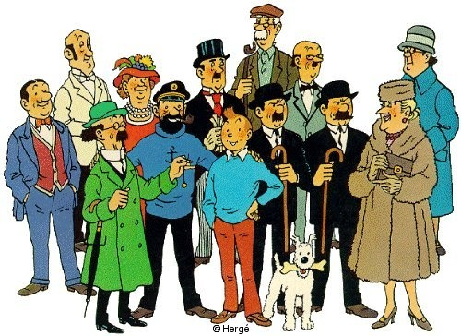

College Reception for graduating seniors in Gray Cage (5:30pm)

May 28 (Sunday): Commencement!

