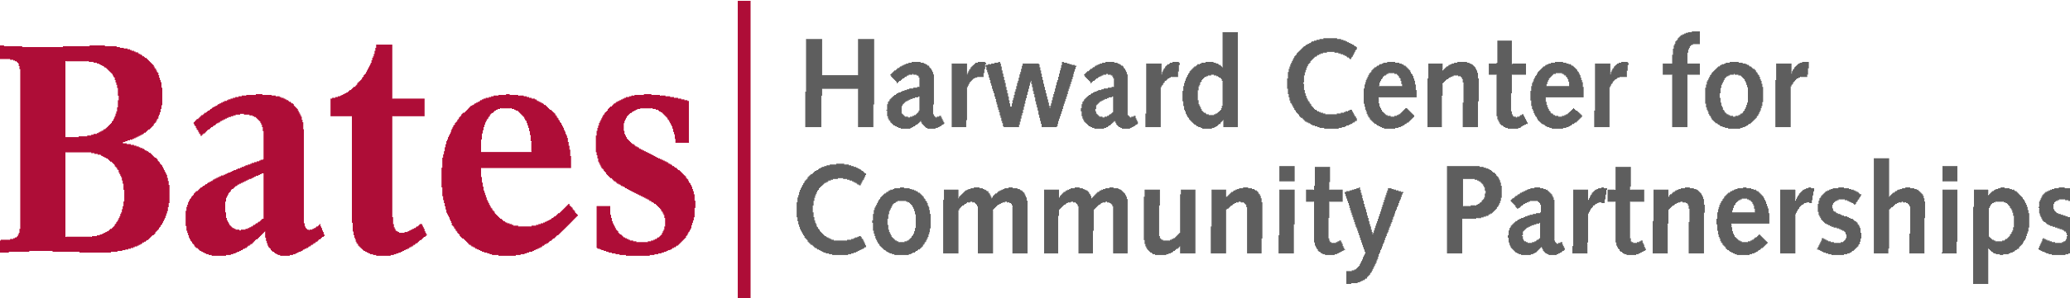

Call for Applications:
2021 Harward Center Action/Research Team

Applications are due via electronic submission by 4:30pm on Monday, December 21, 2020.

The Harward Center for Community Partnerships invites student applications for the Harward Center’s 2021 Action/Research Team (A/RT), to take place virtually from January 11-February 5, 2021. Each A/RT Fellow will work approximately ten hours per week during the four-week period on a select project designed to build capacity for community-engaged work by future Bates College students and others wishing to get involved in the local community. Students who have significant experience with community engagement in the Lewiston/Auburn community will be in the best position to succeed as A/RT Fellows.

This year’s program features these potential projects (depending on experience/skill/interest of applicants):
- Create a research-based Story Map to engage and inform viewers about issue-based work in the local and/or statewide community. (Each Fellow will create one Story Map, making use of existing photos.) Potential issues include:
  - Food access, food justice, food systems
  - Housing, houselessness
  - Racial justice, racial equity
  - K-12 education
  - Lewiston-Auburn history
  - Trails/conservation, e.g. opportunities for outdoor activities/environmental work in L/A
  - Public health, e.g., hospitals, clinics, and key issues such as lead
  - Immigration, e.g., recent immigration/refugee experience; could also put that experience in broader historical context by looking at Irish, Franco, Greek, etc. experience
  - Arts and culture
- Use Google Streets to create a narrated tour of key community-engaged learning sites in the off-campus community—a tour designed to orient Bates students or new L/A residents to downtown Lewiston.
- Curate a “racial equity in local community-engaged work” toolkit (readings, videos, blogs, etc.) designed to help students recognize, understand, and dismantle racism as they encounter it in their community-engaged work in the L/A community.
- Design digital materials and develop strategies for future voter education and mobilization campaigns at Bates.

Applicants with significant community-engaged experience in Lewiston/Auburn, skills that are well-suited for at least one of the projects outlined above, a strong work ethic, and the ability to work both independently and collaboratively are encouraged to apply. A/RT Fellows receive a stipend of $400 for their full participation in the program. During weekly meetings led by Harward Center staff, Fellows develop work plans, evaluate progress toward goals, and brainstorm ways to address challenges.

Scroll down for application.

Call for Applications:
2021 Harward Center Action/Research Team
Application Cover Page

Name: ________________________________________________________________________

Email: ________________________________ Class Year: ______________________________

Preferred Phone: ________________________ Bates ID: _______________________________

Major area(s) of study: ____________________________________________________________

Name of a Bates faculty or staff member who is familiar with your work ethic and quality of work: _________________________________

Name and contact information of an off-campus community member/partner who is familiar with your work:
__________________________________________________________________

Your application must include:

- This cover page.
- A short essay (not more than two pages, double-spaced) describing your interest in the program. Please include the identification of your top two project choices and an explanation of how your interests, experiences, and skills are a good match for these projects. Please also include previous community-engaged experiences, courses, research projects, and/or relevant skills that have helped prepare you for this program.

Please submit your proposal electronically to Darby Ray (dray3@bates.edu) by 4:30pm on Monday, December 21, 2020. Applicants will be notified of decisions by the end of December.

