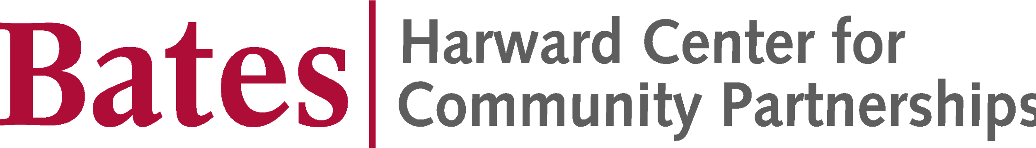

Call for Applications:
2021 DALI x Bates Fellowship

Are you a first or second year student interested in learning programming and design skills for web development? Do you want to apply your skills in a community-engaged setting? If so, apply now for the DALI x Bates Fellowship at the Harward Center for Community Partnerships. Previous experience is not required. First and second year students who will return to campus for Module C are eligible to apply for this first cohort.

DALI x Bates is an exciting new collaboration between Bates and the Digital Applied Learning and Innovation (DALI) Lab at Dartmouth College. DALI trains their students in the software engineering and design skills required to develop digital products for real world partners. Now for the first time, they are bringing their student training and development model to students outside their home campus.

DALI staff will offer training modules for Bates students to skill up in web development and design. Once trained, you will become part of a consulting corps, working in teams to apply your skills to digital projects undertaken in collaboration with nonprofit organizations in the Lewiston/Auburn community. As a fellow, you will complete at least one project by the time you graduate from Bates. These projects may take place within the context of future Community-Engaged Learning (CEL) courses, college-sponsored internships, or under the purview of additional Harward Center projects and fellowships.

The first-ever cohort of DALI x Bates Fellows will undertake a six-week virtual training module beginning on January 20th. The Mini Web Development Course is a 6-week program to teach the art of full-stack web development. You will learn how to build interactive web applications, diving into the world of HTML/CSS, React, Github, Node/Express, styling, and more. The module is extra-curricular and not graded. The training will involve 2 hours of synchronous work via Zoom each week on Wednesdays and Sundays from 6-7 pm, and 3-7 additional hours of work each week, including help sessions, meetings with mentors, and other activities. Participants will need a reliable internet connection and a computer. (If these are obstacles to your participation, please let professor Ray know.) DALI has designated a course mentor just for Bates students in the course, and she will meet regularly with each participating student. Bates and Dartmouth students will attend the synchronous sessions together. Future opportunities for web design training are in the works; until then, you can access asynchronous instruction if interested. You can check out DALI’s preferred tech tools and frameworks here. You will become familiar with many of these in the first training opportunity, and you will be able to utilize your new skills to develop a simple project by the end of the module.

In addition to successful completion of the training module in January-February, Fellows will attend monthly cohort meetings during their remaining time at Bates to learn new skills, discuss prospective projects, reflect on learnings from past projects, and learn about additional training opportunities. During their later years at Bates, Fellows will help coach and support newer members of the corps. DALI x Bates Fellows will receive a $400 stipend upon successful completion of the six-week training module and may be eligible for future stipends as funding becomes available.

There are no prerequisites. This program is open to students with no prior web development/ programming expertise. Students with diverse interests and backgrounds are encouraged to apply. Applicants must be first or second year students planning to return to campus in February 2021 for Module C.

Please note that the final two weeks of the DALI x Bates training module coincide with the first two weeks of Module C. Applicants should ensure there is no direct conflict between their Bates class schedule and the fellowship training times listed above, and that during those two weeks they do not have other major commitments.

Questions about the program may be directed to professor Carissa Aoki (caoki@bates.edu).

Applications are due by 4:30 pm on Friday, January 1, 2021 and should be sent via email to Harward Center director Darby Ray (dray3@bates.edu). SCROLL DOWN FOR APPLICATION.

2021 DALI x Bates Fellowship Program
Application Cover Page

Name:

Email: Class Year:

Preferred Phone: Bates ID:

Do you plan to return to campus in February for Modules C and D?

Major area(s) of study:

Name of a Bates faculty or staff member who is familiar with your work ethic and quality of work:

What is your class schedule for Module C? (i.e., When will your classes meet?)

What other major commitments will you have during the first two weeks of Module C?

Your application must include:

- This cover page.
- A short essay (not more than two pages, double-spaced) describing your interest in the program. Your essay should consider both the overall purpose of the program--to equip students with digital skills for real-world application--and program specifics such as time commitment, consulting corps model, and fellowship requirements. You should also share any relevant experiences, skills, or commitments you have.
- Please paste your essay into this cover page document so you submit only one document, as an email attachment. Name your document as follows: First name, Last name (e.g., Doe, Jane).

Please submit your application in a single document as an email attachment to Darby Ray (dray3@bates.edu) by 4:30pm on Friday, January 1, 2021. Applicants will be notified of decisions by January 11.

