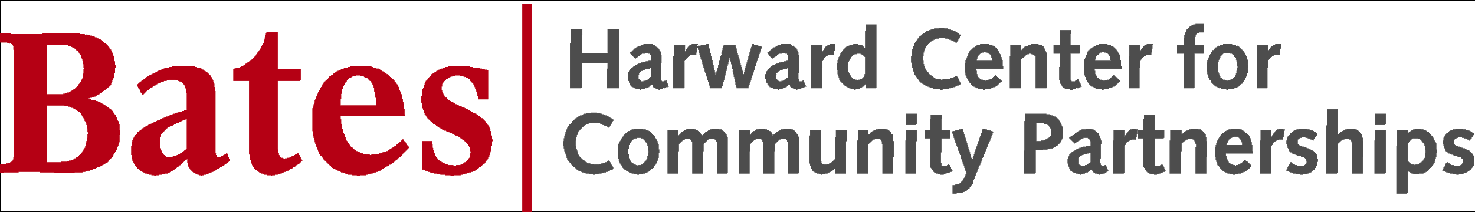

Community Outreach Fellow Application
2021-2022
Application Deadline: April 12, 2021

Community Outreach Fellows serve as part-time members of the Harward Center staff, helping to connect the college to the off-campus community in mutually transformative ways. Each Fellow is responsible for working with Harward Center staff and community partners to coordinate and/or develop site- or issue-based volunteer programs. Fellows also meet regularly to plan programming, report back on their progress, and reflect on their experience. Fellows benefit from leadership training, exploration of community issues through immersive experiences, and hands-on opportunities to develop leadership and project management skills. Each Fellow has the chance to shape programming by contributing innovative ideas and problem-solving skills to community needs. Successful Fellows tend to be deeply committed to community engagement and have the energy and desire to develop and grow community programs in partnership with others.

Community Outreach Fellows will:

- Represent the Harward Center as leaders on campus—recruiting, training, and coordinating other students as volunteers in the community.
- Work to meet the needs of the community and to maintain strong relationships with community partners.
- Work individually and collaboratively to meet program expectations.

These are paid positions ($1,000 per semester). Fellows must meet the following expectations:

- Commit to an average of 6 hours per week of community–engaged leadership work. The time commitment may vary a little from week to week.
- Attend weekly meetings with the Fellows cohort and Harward Center staff, with additional meetings as needed.
- Report regularly on the progress of their program and on other program activities.

Examples of programming on reverse side.

POSITION DESCRIPTIONS

Examples of some of the community leadership positions available are listed below. In addition to volunteer recruitment and coordination, Fellows will participate as volunteers in their programs.

Coordinators for After-School Programming--Support local youth by connecting Bates students to diverse after-school programs. Work with community partners to develop programs that address their needs.

Coordinator for School-Based Programming—Enhance educational experiences for local youth by connecting Bates students to public school programs such as America Reads/America Counts and Montello Book Buddies. Help to lead trainings. Monitor progress. These programs take place during the school day.

Coordinator for Athletics and Mentorship—Recruit and orient students, particularly athletes, to serve as mentors for programs such as M.O.V.E. (created by Bates football coach Malik Hall); Rosati (soccer-based) Leadership Academy; and a lunch program at Lewiston Middle School.

Coordinator for Senior Citizen/Elderly Programming—Help address social isolation and enhance well-being among senior citizens by recruiting and coordinating volunteers for programs like weekly Sunday brunches at Blake Street Towers, and working with staff at local senior centers to develop and connect Bates to creative programs.

Coordinator for Arts Programming—Contribute to the local arts scene by recruiting and coordinating volunteers for art programming with ArtVan (mobile art therapy) and working with L/A Arts to organize Bates student performances for monthly art walks.

Coordinator for Food Security and Nutrition Programs—Make a difference in local food access and security work by recruiting and coordinating volunteers to work with community partners such as the Nutrition Center, New Roots Farm, Whiting farm, and others.

Coordinator for Environmental Justice and Conservation Programs—Support local efforts in this arena by working closely with partners such as the Androscoggin Land Trust and the Stanton Bird Club. Recruit and coordinate volunteers to work on a variety of issues, including trail mapping, cleanup events, and lead abatement.

Coordinator for Legal Reform Programs--Help organize students to get engaged in issues such as prison abolition, access for low-income people to legal aid, restorative justice, and reintegration for returning prisoners. Help develop partnerships and programs with organizations such as Maine Inside Out, Maine Youth Justice, College Guild, the Volunteer Lawyers Project, the Maine Prisoner Re-Entry Network, and the Restorative Justice Project of Maine.

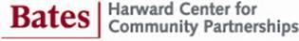

Community Outreach Fellowship

Application

The Community Outreach Fellowships are for one academic year. Fellows are paid to coordinate programs and student volunteers. Your application must be completed no later than Monday, April 12 by midnight. Recommendations are due by April 23.

Each application must include:

- A completed application from you, using this form
- A recommendation from a faculty or staff member (preferably pertinent to your interest in community engagement) using this form
- A recommendation from someone who can speak to your work as a volunteer or community leader, using this form

You are welcome to contact Ellen Alcorn (x8235, ealcorn@bates.edu) to discuss your application.

