Instructions and Tips for employees to complete year end performance reviews

Your year-end performance review is the opportunity for you and your supervisor to discuss goals, accomplishments, professional development plans and rate your performance.
The performance review program is on the internet. This means that you can use any computer to log in.
__________________________________________________________________________________________________
This is the list of steps for the year-end performance review:
- The employee completes their self-review by answering questions, rating themselves on each performance factor and answering 3 development plan questions.
- The manager completes their review of the employee by responding to the answers of the questions, rating the employee on each performance factor and responding to each of the answers to the development plan questions.
- The employee and manager meet to discuss the year-end review and make any edits to the review.
- The employee and manager each sign the review to indicate they have completed all the steps of the year-end review process.
- The year-end review is now complete.
__________________________________________________________________________________________________
There are 2 options for logging into your performance review. In each option, there is the list of steps to log in to your year-end review:
Option 1
- Open an internet browser such as Chrome, IE, Firefox or Safari.

Chrome Internet Firefox Safari
Explorer

- Type in www.bates.edu/hr/performance in the address bar.

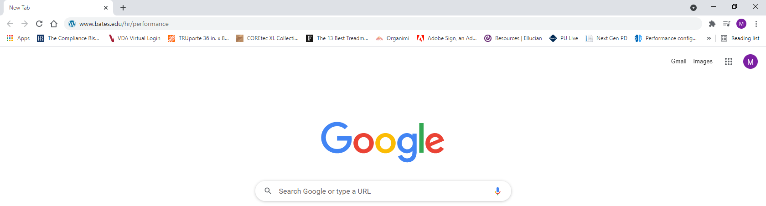

- Click on Log In to PageUp to access your year-end review

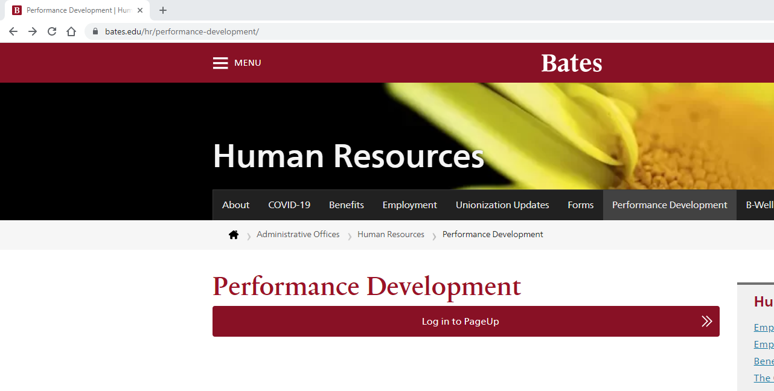

- Enter your Bates username and password. Note: If you have Duo dual authentication you will then get the Duo dual authentication screen. Complete the authentication.

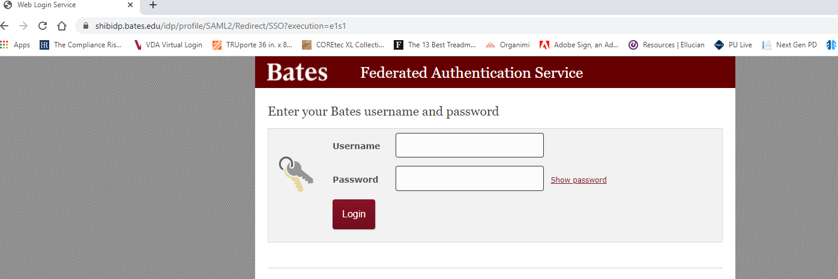

Option 2
- Open an internet browser such as Chrome, IE, Firefox or Safari.
Chrome Internet Firefox Safari
Explorer

- Type in quad.bates.edu in the address bar.
- Log in to Garnet Gateway
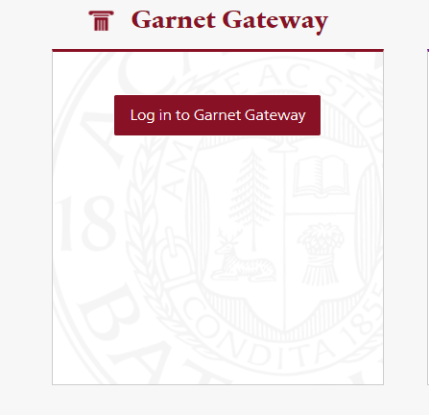

- Click on Training/Development
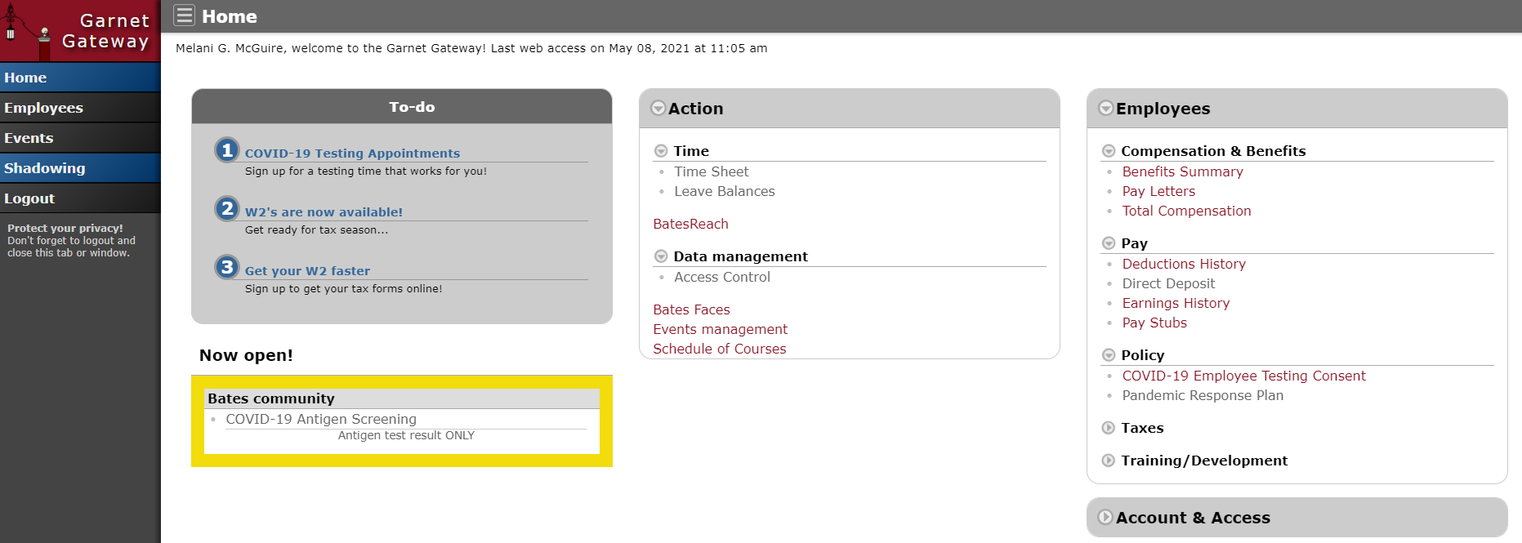

- Click on Performance Development
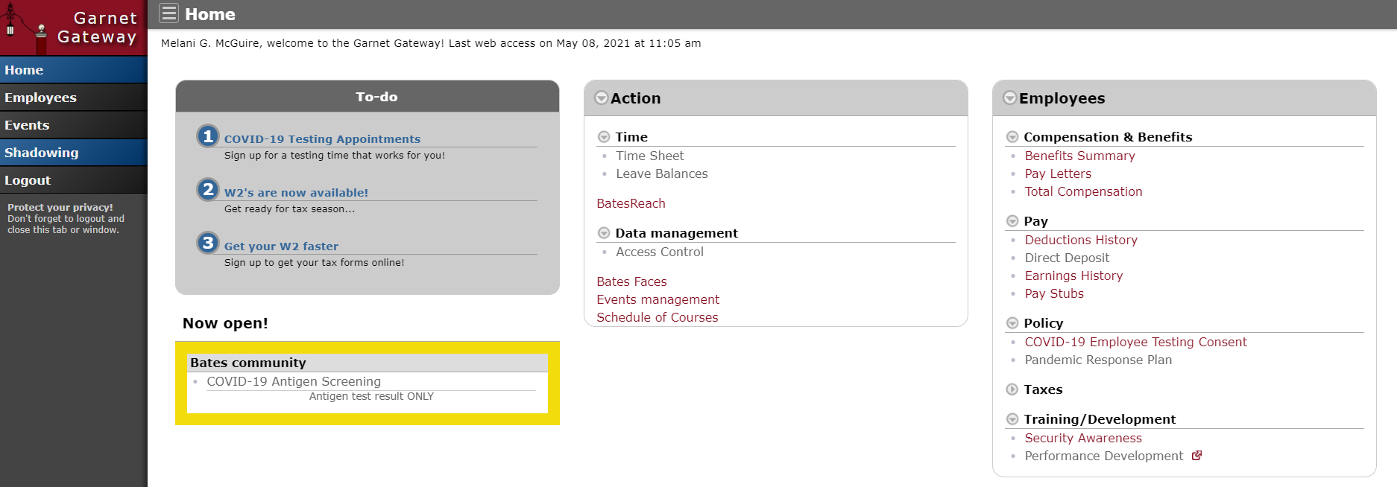

You should now be logged into the Performance Development system.

To begin your Performance Review process:
- Click on '2021-2022 Review Process' in the 'My Performance Reviews' box.
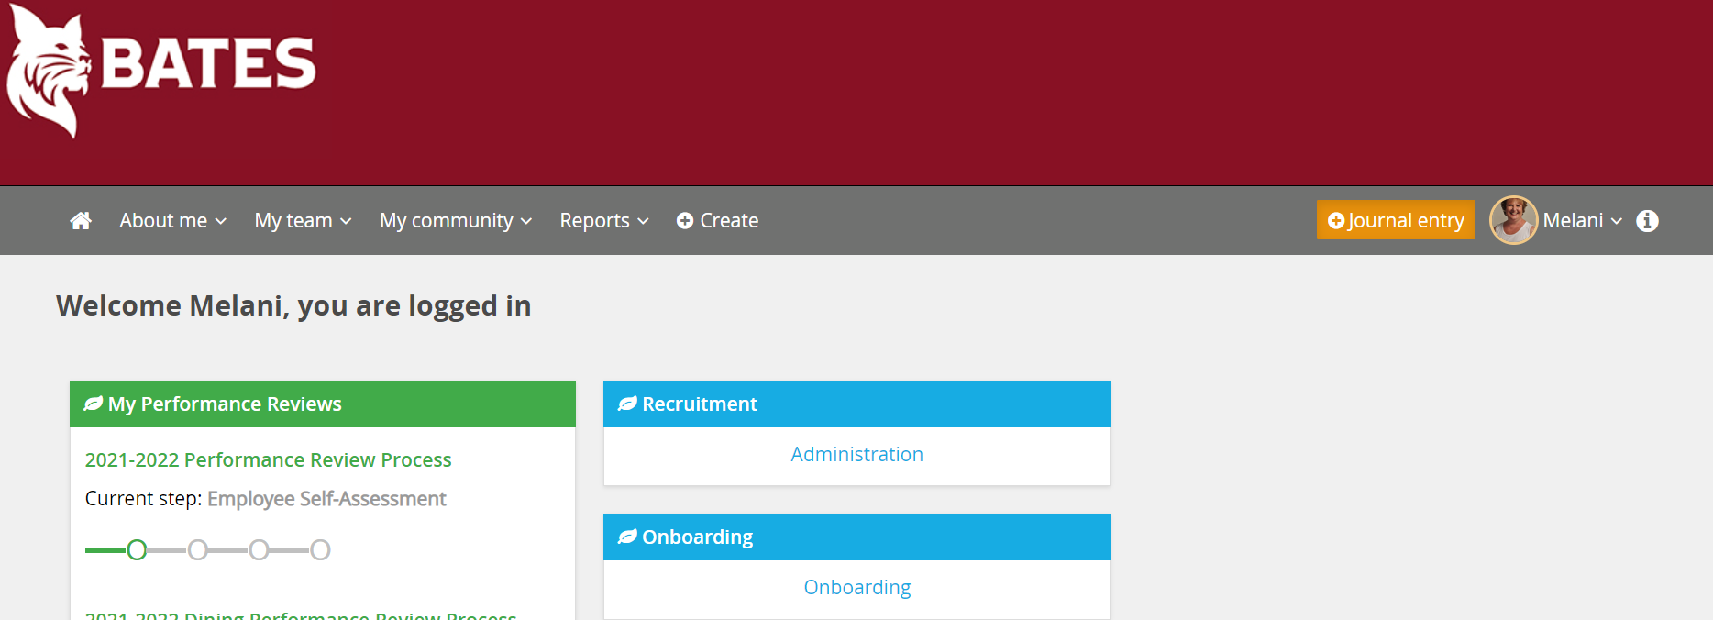

- Read the instructions carefully. Note: you will see the review steps across the top of the page.
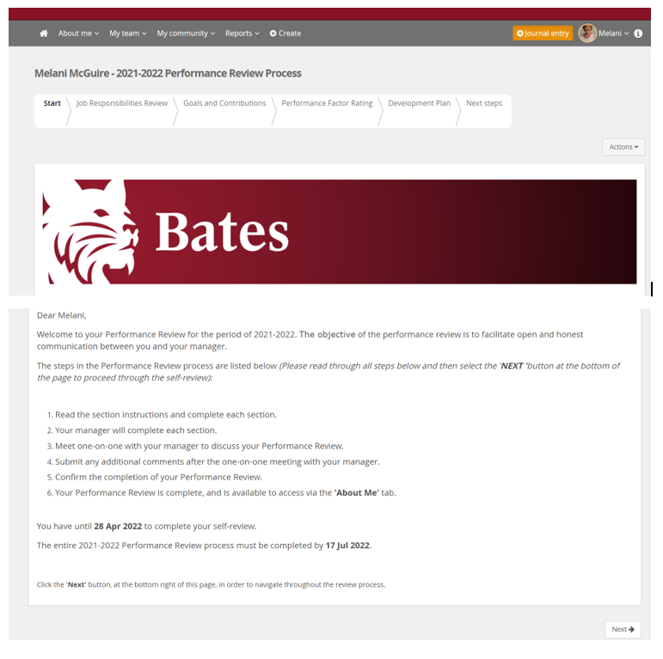
- Click 'Next' on the bottom right of the page.
- Read the instructions carefully for each section.
- Make sure you click ‘Save & Share’ or ‘Save as Private’ after each comment, before clicking ‘Next’ or you will lose any entered comments.
- At the end of each section click ‘Next’ at the bottom right of the page.
- Complete the self-review.
Notes to supervisors
- You will receive an email that your employee has completed their self-review.
- On your home page, you will see a section titled Team Performance Reviews.
- Click on ‘2020-2021 Review Process’ of the person that you would like to review.
- Read the instructions and complete each section by responding to the employees answers to questions and rating them on the performance factors.
- Once you have completed your portion of the review, DO NOT click on ‘Go to next step’.
- Schedule a one-on-one meeting with your employee to discuss results of review.
- Make any adjustments to comments or ratings by clicking ‘Back’ in the lower left until you reach the section you wish to adjust. Make sure to save after changing a comment.
- When the review is finalized, click on ‘Go to next step’ in the lower right corner.
- The employee must sign the review and add any final comments first.
- After the employee signs the review, the supervisor signs the review and it is complete.

Please remember when you finished working on your review that you log out by clicking on the down arrow next to your name and click on Logout.

