Electronic Regulatory Consent Form
By consenting to receive your tax statement(s) electronically, you agree to go to Garnet Gateway between January 31 and October 15 of the appropriate year to print each of your tax forms online.

Your consent for each electronic statement will be valid for all subsequence tax years unless revoked by you, upon termination, or this service is not supported in a future given tax year.

To consent to receive your tax statement electronically, please complete the following steps:

- Log on to Garnet Gateway and click on the employee’s tab on the left-hand side.
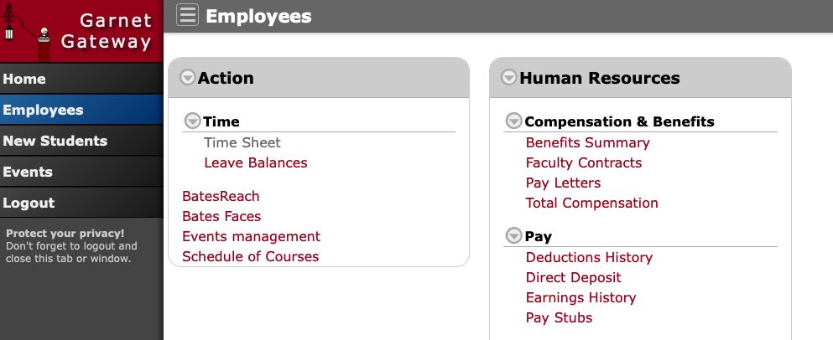

- In the Human Resources tab, under the Taxes heading, click on “Tax Forms Consent”.
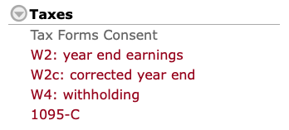

- Read the form, check-off the boxes and click submit.
